Accessing Learning and Development

There are numerous learning packages available to help support an employee’s ongoing development. Training, courses, E-learning and learning resources covering a full range of skills, competencies and knowledge areas are available to access via the My Learning area on Intouch.

Managers are encouraged to familiarise themselves with the training available and actively promote and encourage employees to access appropriate learning following their VIP conversations.

Accessing Learning Courses

To be able access Learning and Development, you first need to access My Learning to be able to see the courses available.

To be able to see the advertised courses you firstly need to log on to My Learning.
To access My Learning you need to go on to InTouch and click on My Learning and then from the menu click on My Learning

After clicking on My Learning you will then get two options one for Cumbria County Council Employees or All Other Users. Click on Cumbria County Council Employees to log in page.

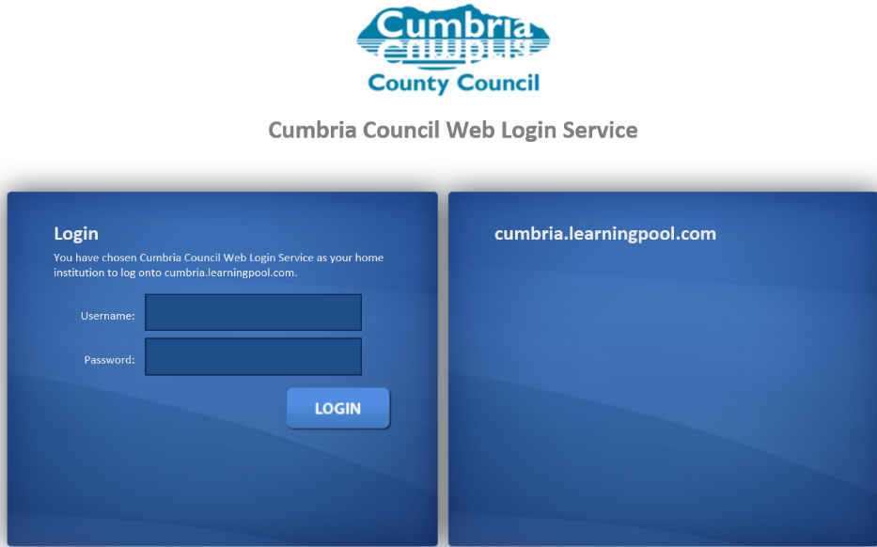
You may then receive a log in page where you need to enter your username and password for your laptop.

Exploring Available Courses

Once you have logged on to My Learning you then need to click on the heading which relates to the training you are looking for.

After you have clicked on the heading you will then get a list of sub-categories or a list of courses, from this list you need to click on the name of the course you are wanting and it will take you through to all the courses that are available with this title.

If you are unable to find the course under any of the headings, at the top of the page there is a Search Courses box where you can type the name or subject of the course and it will bring up every course that relates to what you have put in.

E-Learning courses can be accessed directly from this page. However, if you have found a course of interest and want to book to attend this, you need to book this through the My HR package.

Booking on to a Training Event

Once you have found a course of interest, the individual attending the course needs to book onto the course using My HR.

Once you have logged into MyHR click the Career & Development Tab at the top right of the screen.

You will then be taken to your personal learning page, where you will find the option to search for courses.

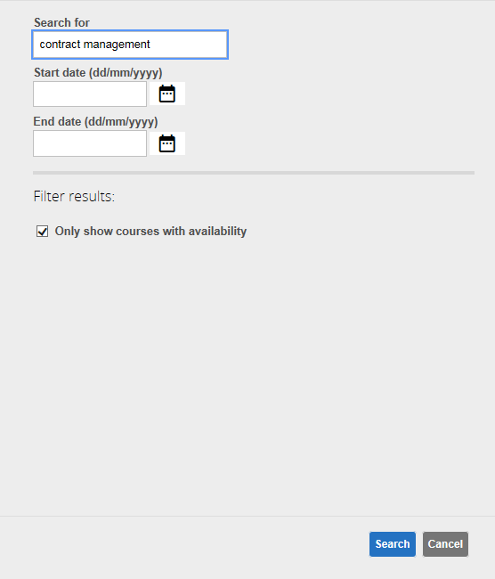

Once you have selected this option, a search box will appear. Type the name of the course into this box and click or tap on search.

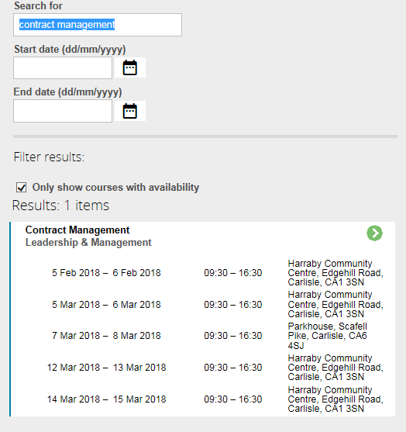

You will then be shown the available dates. Click or tap to see the individual course information.

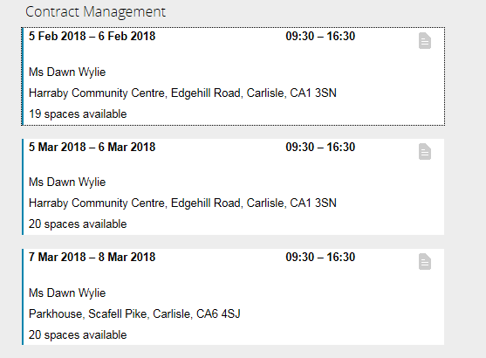

Click or tap on the date you wish to book on.

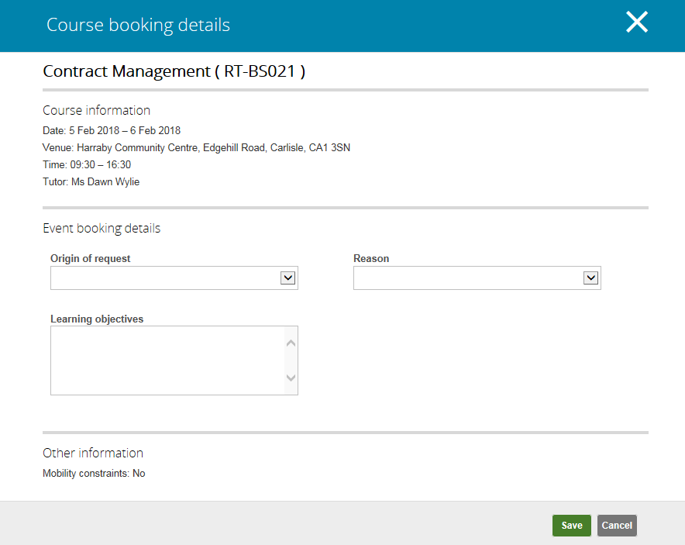
This will then take you to the course booking page. Fill in the origin of request and the reason for booking the course, then click save.

Once you have clicked on save, a notification will be sent to you and your manager. If the course requires manager’s approval you will receive notification from My HR once approval has been authorised.

