HR Guidance

Valuing Individuals and Performance

Version Control | Changes Made | Author
Version 1  May 2019 | New guidance | People Management
Version 2  October 2022 | Updated guidance | People Management

Introduction

Conversations about performance, goals, development and wellbeing are essential to ensuring that people have the clarity, support and recognition needed to confidently deliver their role and deliver our services.

The Valuing Individuals and Performance (VIP) approach promotes regular and informal conversations which focus on strengths, wellbeing, performance and development. At the end of the year, a summary of VIP conversations will be brought together under a VIP Summary Appraisal where employee and managers will agree development and objectives for the year ahead.

VIP conversations form part of the engagement, recognition and development culture within the workforce and both employees and managers are encouraged to seek feedback and discuss performance regularly both on an individual and group/team basis.

Scope

This procedure will apply to:

- All employees

This procedure applies to all NJC and grey book employees of the county council and all school based staff for whom there is no specific procedure laid down in national or local conditions of service.

It is expected that governing bodies of all community and voluntary controlled schools would adopt this procedure. Foundation and voluntary aided schools and academies are encouraged to do the same.

Principles

- Conversations about performance matter and should take place regularly
- Managers, individuals and teams are expected to participate in the process. Anyone can initiate or arrange conversations about performance and are encouraged to do so.
- VIP conversations should aim to be an empowering, supportive and helpful experience.
- Conversations and feedback should focus on building and utilising an individual’s strengths and natural talents.
- Team members are encouraged to use their strengths to support everyone’s development.
- Objectives should balance the needs of the services and maximise the talents and development requirements of the individual.
- Formal, VIP summary appraisals should take place annually and the whole period should be reviewed- not just recent or isolated events.
- Capability concerns should be addressed under the capability procedure
- All employees are treated fairly and equally

Process

The VIP process is summarised below:

- Line managers schedule in opportunities to have VIP conversations with the individuals and teams they manage. VIP conversations can take place within existing meetings, such as 1-2-1’s, supervisions or alternatively separate meetings can be arranged.
- Line managers and employees discuss and identify the performance and development areas they will focus on throughout the year. These areas should be relevant to the individual and their contribution to the organisation.
- Throughout the year, VIP conversations take place covering the agreed topics as a minimum. Line managers and employees should refer to the “Making Conversations Count” Toolkit available online. This contains a suite of “conversation starters” and team tools available to help support the conversations.
- At the end of the year, a VIP Summary Appraisal takes place between the line manager and employee which summarises performance conversations and explores developments and goals for the year ahead.
- Line managers and employees complete and agree the VIP Summary Appraisal form.
- Line managers provide employees with a copy of the VIP Summary Appraisal form and attach this to their ITrent record, ensuring the date of the VIP appraisal has been recorded. In a School, any documents should be retained in an appropriate manner as it is recognised that systems will vary from School to School.
- Following the completion of all VIP summary appraisals, managers complete a Team Theme template and provide some collective feedback to their senior manager so this can be collated and fed up to Assistant Directors. In a School, any feedback should be provided to the Headteacher/Chair of Governors as appropriate.

Scheduling VIP conversations

Throughout the year, managers should ensure there are appropriate opportunities to meet with employees and have VIP conversations both in a 1-2-1 and team / group environment.

Managers may wish to schedule in specific VIP sessions, alternatively, VIP conversations can take place within existing meetings such as 1-2-1’s and supervisions, team meetings and away days.

If throughout the year, individuals feel they would like additional opportunities to have VIP conversations, they are encouraged to raise this with their manager and / or arrange separate meetings.

Whilst regular 1-2-1s and team meetings should take place across all services, there is no “one-size-fits-all” guidance relating to the frequency, length and nature of VIP conversations. These should be arranged locally by the line manager to ensure they complement the services being delivered.

Managers should refer to any local guidance which may set out any requirements for meetings. For example, the Supervision Procedure.

Topics for VIP Conversations

Managers and employees should discuss and identify the performance and development topics they will focus on throughout the year. For example, they may wish to have separate sessions focusing on “customer”, “working together” and / or “communication and engagement” whilst others may wish to focus sessions on “leadership” and “managing resources”. They should aim to cover the VIP areas that are particularly vital to the individual’s role, aspirations and contribution to the organisation and council plan objectives.

VIP conversations should also reflect employee wellbeing and aim to identify the needs and aspirations of individuals along with the services they are delivering.

The “Making Conversations Count” toolkit is available online. It contains 1-2-1 and team based tools which allow a focused conversation to take place around the areas that are key to the delivery of our services and council plan. They focus on the organisation’s key competencies, behaviours and ways of working.

Given that performance conversations will happen regularly and informally, each VIP conversation should aim to cover just 1 or 2 topics. This allows the conversation to be focused on a particular performance area of importance. E.g. Customer, or Leadership

A successful VIP Conversation would recognise an individual’s strengths, needs and successes and identify how areas of talent can be used effectively to enhance the performance of the service / school. This can be achieved by aligning goals against areas of natural talent, setting objectives and providing support and routes available to develop themselves and /or mentor others.

Maximising Performance by Focusing on Strengths and Talents

All individuals have areas of natural strengths and weaknesses which are unique. The Valuing Individuals’ and Performance approach is founded on a Strength-based-model which maximises performance by encouraging a focus on an individual’s natural talents, expertise and skills rather than any deficits or problem areas.

The tools available to support VIP conversations focus on an individual’s abilities. They help to explore how an individual’s strengths and natural talents can be best developed and used to deliver their services, teach, support others and maximise their performance and the performance of others.

Applying a strength-based approach is about recognising everyone’s strengths and understanding that everyone can both teach and learn from another. This approach ensures individuals feel valued, empowered and supported to work as a team and perform at their best.

When scheduling VIP conversations, managers should prioritise the discussions around the areas of natural strength within the individual or the team, with a focus on how they can use that strength to enhance the overall performance and contribution to the service /school.

The Annual VIP Summary Appraisal and Feedback

On a rolling 12 month basis, employees and managers will meet to discuss their performance from the last 12 months under a VIP summary appraisal. The purpose of the VIP Summary Appraisal is to review the previous year and plan for the year ahead.

VIP summary appraisals should take place in an appropriate setting - ideally a meeting room which is private and free from interruption from others.

Before the VIP Summary Appraisal meeting takes place, both managers and employees should take time to reflect on the individual’s contribution, including their achievements, strengths and development. They should summarise the individual’s overall performance and reflect this in the form.

At the VIP appraisal meeting, managers and employees will come together to review their summaries and agree any actions needed to support performance, personal and /or team development.

Managers and employees should complete the short VIP Summary Appraisal form and ensure they record that they have completed their appraisal on ITrent and attach their VIP Summary Appraisal Form to iTrent. Employees should receive a copy of their VIP Summary Appraisal form. More detail and guidance on the VIP Summary Appraisal can be found in Appendix 1. In a School, any documents should be retained in an appropriate manner.

Setting Goals

As part of your ongoing VIP conversations and the annual summary appraisal, managers and individuals should consider setting goals. Goals will be more relevant in some circumstances and roles than others.

Goal setting requires outlining an action plan of things an individual should aspire to achieve over a forthcoming period. Goals should go beyond the immediate tasks required within the role. Goals should always support the delivery and/or advancement of services and be in keeping with the outcomes we want to achieve as an organisation /school, which are outlined in our council plan.

Goals should help stretch and grow skills, enhance wellbeing and maximise the performance and delivery of services within teams. In setting the goals, you may wish to consider the following:

Task Based Goals will outline specific work to be delivered, for example, a project that supports the team and service’s objectives.
Skills and Development Goals will focus on skills and / or personal styles that can be developed to enhance the employee’s performance and career aspirations.
Personal and Wellbeing Goals will explore stresses and focus on wellbeing and /or work-life balance actions that will support the employee to perform at their best.

Any goals set should be clear, realistic and achievable within the set timescale. They can be short, medium or long term goals and should always be revisited regularly as part of your ongoing VIP conversations.

Task based goals would ideally be collectively shared within the team so there is support and clarity over roles and responsibilities.

Accessing Support

During your VIP conversations and in setting goals, managers and employees should consider any dependencies or support needed to achieve the goal and how this support can be put in place. For example; training, mentoring, wellbeing, new systems / approaches etc.

Before VIP conversations take place, managers are advised to familiarise themselves with the support programmes available, and how to access these.

Guidance on how to access Cumbria County Council Wellbeing Support as well as Learning and Development can be found on intouch / Employee Support Pages.

www.cumbria.gov.uk/employeeinformation/Valuing_Individuals_and_Performance

Schools should refer to their local arrangements in place to support development and wellbeing.

Team Themes

Managers should aim to complete all of their team’s VIP summary appraisals within a rolling 12 months.

When all VIP summary appraisals are completed it is important that managers reflect on the information that has been discussed and consider the collective feedback from the team. Managers should complete the Team Theme template to identify any emerging themes or development requirements relevant to the overall performance of the team. The Team Theme template should be forwarded to their senior manager/Headteacher who will collate this information for their service area.

DMTs/ Governing bodies will collate and review the Team Theme feedback annually to establish any emerging themes arising across their service area/ school. These themes will be used to inform and agree any appropriate actions needed to support the workforce in their areas.

At a team level, managers should discuss any emerging themes arising that require some immediate action with their senior manager/ headteacher. For example, it may be apparent following all appraisals that there is a new training need, system improvement or resourcing requirement needed within the team.

Appendix 1: The Annual VIP Summary Appraisal

The purpose of the VIP Summary Appraisal is to discuss and capture a summary of the ongoing VIP conversations between the employee and their line manager over the previous 12 months.

Scheduling the VIP Summary Appraisal Meeting

New Starters - The probation process is designed to formally monitor and support performance and development within the role and therefore it is appropriate to allow that process to conclude before any new performance objectives are discussed. New employees to the organisation would usually have their first VIP Summary Appraisal 12 months after their start date.

Periods of Leave such as long term sickness, maternity, adoption etc.- If an employee is absent at a time when their 12 month VIP Summary Appraisal is due to be undertaken, managers should arrange the VIP Summary Appraisal to take place at an appropriate time following their return. Each case is different but this would usually be undertaken within 3 months of their return. In cases where there has been a long period of absence, the focus of the VIP Summary Appraisal will be more forward looking rather than a summary of past VIP conversations.

Internal Transfers- employees should receive a VIP Summary Appraisal every 12 months, even if they have changed roles within the last 12 months. In circumstances where employees change line management, a hand over discussion should take place between line managers to share relevant performance information around for example, strengths, development, personal goals etc.

Dual Roles-
- For employees that have more than 1 job within the council, but the same line manager, one VIP Summary Appraisal meeting should cover both jobs. Line managers must ensure that both jobs are marked as having a completed appraisal on ITrent/ relevant school system.
- Where employees have more than 1 job and have different line managers, the following can apply:
  - 2 separate appraisals are conducted by each respective line manager or;
  - 1 appraisal meeting is conducted by both managers or;
  - In cases where employees have a main contract of employment and an additional contract on a supply basis or substantially lesser hours, the appraisal meeting can be conducted by the “main” manager, with written contribution and feedback from the employee’s other line manager.
    - Whilst, the main manager undertakes the appraisal, both managers must ensure that the appraisal completion information is recorded in Itrent against both roles held by the individual.
- In circumstances where employees have 1 role, but more than 1 manager, appraisals can be undertaken by either one or both of their line managers.

VIP Summary Appraisal Meeting

The VIP Summary Appraisal will cover 5 key areas and the main points within the conversation should be captured on the VIP Summary Appraisal form:

- Individual Summary and feedback– employees should capture their achievements, strengths and performance. They can also provide any feedback to their manager, including any support they may need or concerns they may have.

- Manager Summary and feedback – this provides the line manager with an opportunity to summarise the employee’s achievements, strengths, productivity and contribution to the team. Where applicable, they can also share and discuss any feedback gathered from the individual’s colleagues or customers.

- Wellbeing – this provides the employee and manager with the opportunity to summarise any points relating to their resilience and wellbeing, particularly focusing on ensuring an appropriate level of work life balance. Individuals can discuss any changes in work they feel could be made to ensure they keep well and resilient.

- Personal Development and Career Aspirations– this provides employees and managers with an opportunity to discuss their aspirations, personal development and how they can utilise their strengths to develop others. The employee and line manager can discuss and summarise any development requirements over the coming year, and establish how these will be undertaken.

- Goals- this provides employees and managers with an opportunity to focus on goals and work objectives. Goals can outline short, medium or long term ambitions. Managers and employees should review and revisit these objectives regularly during their VIP conversations throughout the year.

Recording Appraisal Information

Following an appraisal meeting managers MUST record appraisal information on the appropriate system for their employee. For all employees working within CCC, managers should use iTrent People Manager within MyHR.

ITrent recording

The record must provide the date the appraisal was completed and you should save a copy of the VIP Summary Appraisal on the employees iTrent Record.

On People Manager, the appraisal recording section can be found under the Learning and Performance section on the Home Page as shown below:

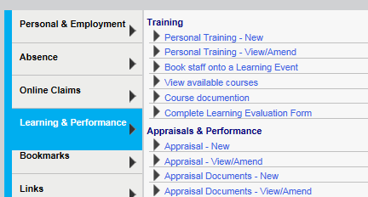

Select “Appraisal – New” and complete the appraisal form for the employee as illustrated below:

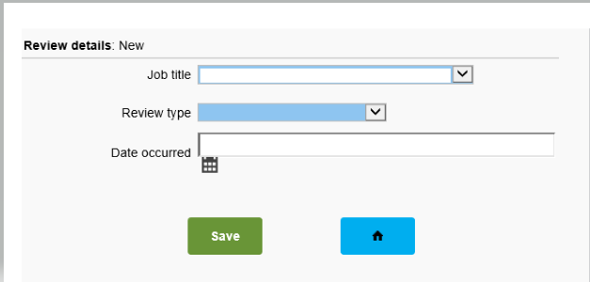

Under “Review Type”, select “Summary Appraisal – Annual” and the input the date this occurred.
Now attach a copy of your appraisal form by selecting “Appraisal Documents – New” to attach a copy of the VIP Summary Appraisal Form:

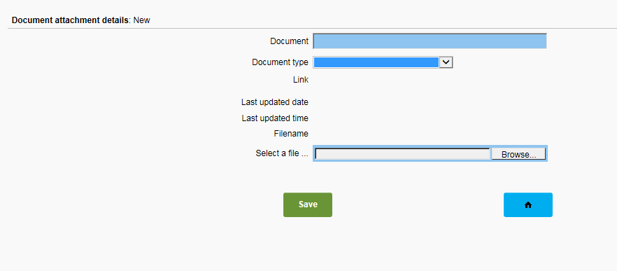

Transitioning From the old Style Appraisal

In previous years a different appraisal form has been in place and may have been completed as part of an individual’s former appraisal. If this is the case, then it is easy to transition to the new form. In the previous appraisal form managers and employees should review Section 2 (My Objectives for the Year Ahead) and summarise the outcome of these on the new VIP Summary Appraisal Form in Section 1 & 2 (the Individual Summary and the Manager Summary). The new goal setting template on the back of the appraisal summary form is available to capture new goals for the year ahead. The rest of the appraisal can be completed using the new VIP Summary Appraisal Form.

