

**HR Guidance**

**Voluntary Redundancy**

Introduction

1. Voluntary redundancy (VR) is the Council’s preferred way of reducing the workforce by voluntary means and may be offered to employees as an opportunity in the following scenarios : -

* Within a restructure situation
* Where the Council opens a VR window to all or specific groupings of employees in order to achieve agreed savings

1. This guidance document outlines : -

* the Councils’ VR scheme
* eligibility
* the application process and approval process for both
  + reshaping
  + corporate VR windows
* Responsibilities of employees and managers.

1. It is important to note that the processes for VR applications and approvals are different for both corporate and reshaping VR windows. The processes for both are clearly outlined within this document.

**Purpose**

1. The Council is at a key stage of its reshaping journey and faces the difficult task of implementing the savings agreed in the Medium Term Financial Plan. The objective of the VR scheme is to facilitate a reduction in the number and cost of employees within the Council in order to achieve the agreed savings.
2. The VR Scheme is selective and will be operated entirely at the discretion of the Council. When determining acceptance or non-acceptance of a VR application an approval process will take account of relevant factors that may include the balance of experience and skills to be retained to ensure business continuity. There is therefore no guarantee that an application will be approved and there is no right of appeal against decisions.

Eligibility

1. Employees may be eligible to apply for VR either through;

* A corporate window
* Reshaping

1. Within both of the above routes, employees will be notified when the opportunity to apply for VR arises. The VR window will be open for a specific period of time, the exact dates of the opening and closure of the window will be communicated at the time.
2. Eligibility Criteria within a corporate window may vary at different dates. Eligibility Criteria may be based on the following but this is not an exhaustive list : -
   1. Service Area
   2. Post Grades and salary
   3. Job Families
3. Applications will not be accepted from individuals who are already under notice of leaving employment with the council or whom have given notice to resign.
4. Employees may withdraw their application at any time during the process up to the time at which they sign their redundancy offer letter. After that point any request to withdraw would have to be approved by a Corporate Director.
5. Managers are required to contact all employees including those who are currently on leave, sickness, adoption, paternity etc. to ensure that they are aware of the VR scheme and timeline and process for application submission.

[**Voluntary**](http://www.intouch.ccc/elibrary/Content/Intranet/536/671/5053/6001/41410105256.doc) **Redundancy Benefits**

1. The financial benefits to which employees made voluntarily redundant will be entitled are set out in the [Redundancy and Early Release Policy.](http://www.intouch.ccc/eLibrary/view.asp?ID=58998)
2. In cases where employees with two or more years’ continuous Local Government Service are granted voluntary redundancy they will receive redundancy pay based on the statutory redundancy pay multiplier, using actual weekly pay instead of the statutory maximum. It should be noted that the actual weekly wage will be capped at £1,000 gross per week. A compensation payment based on a multiplier of 1.5 will be applied to the statutory calculation. So for example where the statutory scheme provides that an employee should receive 10 weeks wages they will receive an additional 50%. This gives a total of 15 weeks (10 weeks redundancy pay and 5 weeks compensation).

Example: Redundancy Pay 10 weeks’ pay

Compensation 5 weeks’ pay

Total Voluntary Redundancy Payment = 15 weeks’ pay

1. No employee shall receive a total payment of less than £1,000, or pro rata if part time.
2. The actual weekly wage is that which the employee is entitled to under the terms of their contract at the calculation date. The calculation date is the date on which the employer gives the employee the minimum notice to which they are legally entitled. The actual weekly wage will be calculated as follows : -

* Where hours of work do not vary weekly wage will be calculated based upon basic salary whereby the annual salary is divided by 52.14
* Where hours of work vary from week to week weekly wage will be calculated using basic pay received within the last 3 month period

1. Years of service are defined by the Redundancy Payments (Continuity of Employment in Local Government etc) (Modification) Order 1999. This provides that, for mainstream local government staff, continuous service within local government and with a number of other prescribed associated bodies shall be taken into account in respect of entitlement to and calculation of a redundancy payment.
2. Under the Local Government Pension Regulations a pensionable employee whose service is terminated on the grounds of redundancy and who is aged 55 or over is entitled to immediate payment of pension benefits, without reduction, in accordance with the Regulations.
3. The Council has provided a VR calculator to assist employees in obtaining a rough estimate of the voluntary redundancy payment which they would receive if their application for voluntary redundancy is approved. It is very important to note that this tool provides a rough estimate only – should an employee’s application be approved they will be provided with a more accurate estimate. The VR calculator can be accessed via [VR estimate calculator](http://www.cumbria.gov.uk/eLibrary/view.asp?ID=54167).
4. In order to use this calculator employees will need to have the following information : -

* date of birth
* reckonable service date
* proposed leaving date
* full time equivalent salary
* contractual weekly hours.

1. Employees can obtain a personal pension estimate by using the ‘Your Pension Service’ calculator on the Member Self Service Pensions website. However, please note that this calculator will not always be able to provide an estimate based on your highest entitlement, for example if you have previously earned more than you currently earn.
2. To log on to Member Self Service, or to register for first time use, please go to the [LPPA Website](https://www.lppapensions.co.uk/contact/). You will find easy to follow instructions on the site. You will require an activation key to access Member Self Service, once registered the activation key will be sent to your home address. If you have any pension queries please contact <https://www.lppapensions.co.uk/contact/>
3. **Process for VR through Reshaping**

Application, Approval and Outcome

1. In order to make an application during a VR window linked to reshaping, employees need to raise a VR application ticket via the Service Centre Portal using the following link, If employees do not have access to the Service Centre Portal they can contact the Service Centre directly on 01228 223333, to make an application.

1. The following information will be required when making an application : -

* Post title(s) – of the posts VR is being applied for
* Proposed leaving date – the date the employee would like to leave

The VR application ticket will look like this : -

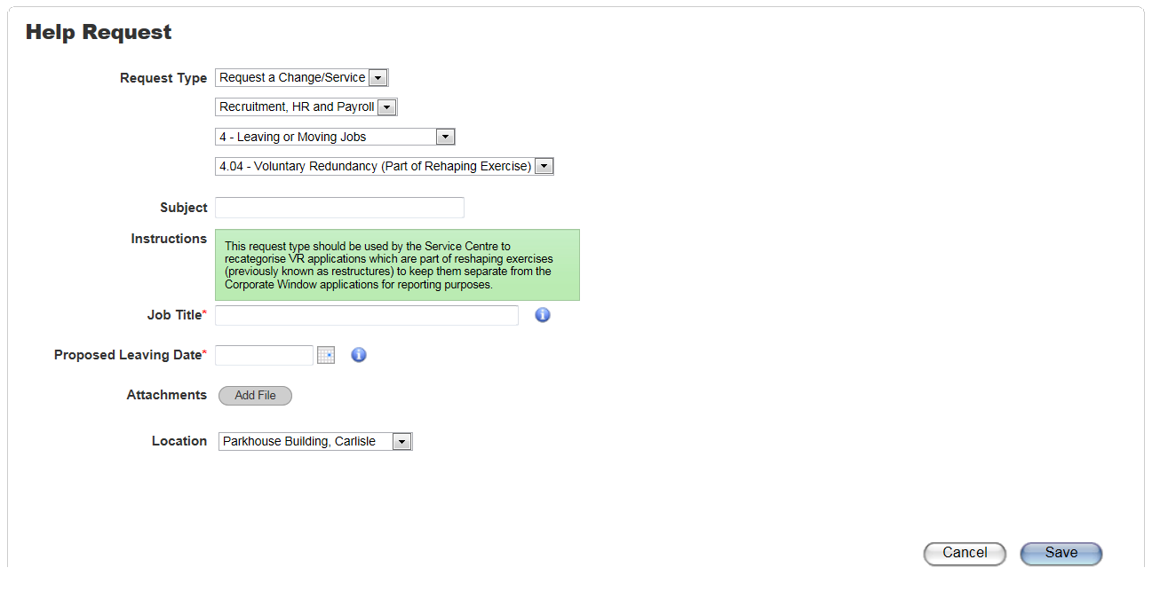

1. Within 48 hours of submitting an application employees will receive a letter via email acknowledging receipt of the application with information regarding next steps.

1. The Lead Manager of the reshaping project will ensure that appropriate consultation takes place following the Consultation Meeting section of this document.
2. All VR applications will be considered by the Lead Manager and will be submitted to the Corporate Director Resources and Transformation for final approval. The financial implications and impact on the service will be fully considered before a final decision can be made on the outcome of the application.
3. In cases where applications are approved employees will receive an offer letter outlining estimated VR figures and where appropriate, estimated pension figures. Employees will be required to consider the offer and confirm their response within 7 working days.
4. If employees do not respond within the allocated timescales managers will be notified and asked to contact employees for a response. It should be noted that the Council reserves the right to withdraw the offer of VR for all employees failing to respond within the allocated timescales.
5. In order to accept or decline an offer of VR the employee will be asked to confirm their decision on their VR ticket, a link to the ticket will be provided in the offer letter. The decision should be clearly entered on to the ticket, for example, ‘I accept the VR offer’ or ‘I decline the VR offer’. In cases where the offer is rejected employees will be required to provide reasons for their decision. The Service Centre will confirm receipt of the response.
6. The Lead Manager will ensure the relevant manager follows the Accepted Applications section of this document to process the final stages of all accepted applications.

**Process for VR through a Corporate Window**

Application Process

1. In order to make an application during the corporate window, employees need to raise a VR application ticket via the Service Centre Portal using the following link, [Apply for VR](https://servicecentre.cumbria.gov.uk/helpdesk/WebObjects/Helpdesk.woa/wa/TicketActions/new?rt=124&subject=VR%20Application).
2. The following information will be required when making an application : -

* Post title(s) – of the posts VR is being applied for
* Proposed leaving date – the date the employee would like to leave

The VR application ticket will look like this : -

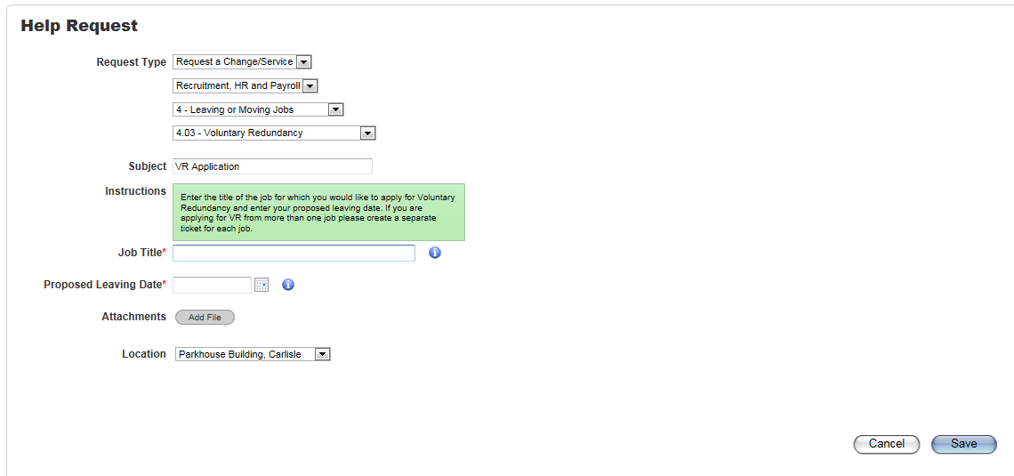

1. If employees do not have access to the Service Centre Portal they can contact the Service Centre directly on 01228 223333, to make an application.
2. Within 48 hours of submitting an application employees will receive a letter via email acknowledging receipt of the application with information regarding next steps. It should be noted that it may take up to 12 weeks to process and approve an application and during this time updates regarding the progress of individual applications will not be issued. If no correspondence has been received after 12 weeks of making an application, employees may contact the Service Centre for an update or with any queries.
3. Assistant Directors will receive weekly reports containing the details of applications received from employees within their service areas. They will then discuss the applications with Senior Managers. Management should consider the impact of the application on the teams and services as well as giving thought as to how the VR could be supported. If the post cannot be deleted consideration should be given to alternative ways of achieving the saving, for example, by deleting a different post.

Consultation Meeting

1. Senior Managers must ensure they offer a one to one meeting to all reports who have made a VR application in order to comply with statutory requirements. The employee may have representation at this meeting from either a work colleague or a Trade Union Representative. The purpose of the meeting is to discuss the application and provide both the manager and the employee the opportunity to ask and respond to questions.
2. This meeting **must** take place prior to the employee accepting the VR offer so that they have had the appropriate opportunity to discuss their application and raise questions as appropriate. The manager must record the date of the meeting on the employees Trent record. To access the relevant section on Trent follow the guidance provided at point 41 within this document.
3. If the employee cannot attend the consultation meeting on the initial date proposed, it would be reasonable to reschedule the meeting at least once.
4. If an employee is currently absent from work for any reason e.g. absence, maternity, managers will need to visit them either at home or at a mutually acceptable venue.
5. If employees do not want to attend a consultation meeting, they cannot be forced to do so. In such circumstances managers should obtain written confirmation from the employee to confirm that they have been offered a meeting and have declined. Managers must clearly record on the employees Trent record (following the guidance at point 26 of this document) that the offer of a meeting was made and the employee did not wish to attend.
6. To access the relevant section of the employee’s Trent record you will need to log on to People Manager. On the first screen managers will see the following: -

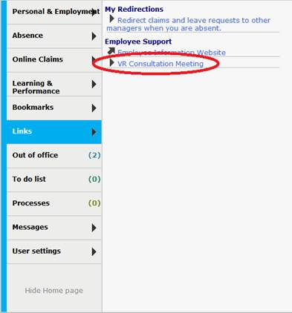

1. Senior Managers will need to click on the Voluntary Redundancy Application Details link then search for the employee and select their position (as with normal People Manager activities). Once the person and positon has been selected they will need to click on the Voluntary Redundancy Application Details link again and the following page will be displayed : -

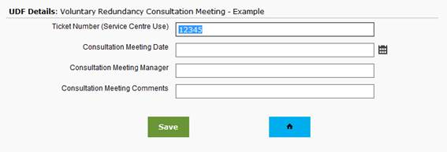

Approval Process

1. In order to gain full approval to be released from employment on VR through a corporate window, applications will be considered using a 3 stage process **: -**

* Stage 1 - Directorate Management Team approval
* Stage 2 - Corporate Director Panel approval
* Stage 3 – Lead Member Panel review

1. At each stage of the approval process the panels will consider the financial implications of approving the VR and the impact on services. Only when this information has been fully considered can a decision be made on the outcome of the application.

Application Outcome

1. Employees will receive a letter confirming the outcome of their application once the approval process has been completed. The letters will be issued via email. Managers will be provided with copies of the letters so they are aware of the outcomes and to enable them to respond to any queries or concerns.
2. In cases where applications are approved employees will receive an offer letter outlining estimated VR figures and where appropriate, estimated pension figures. Employees will be required to consider the offer and confirm their response within 7 working days.
3. If employees do not respond within the allocated timescales managers will be notified and asked to contact employees for a response. It should be noted that the Council reserves the right to withdraw the offer of VR for all employees failing to respond within the allocated timescales.
4. In order to accept or decline an offer of VR the employee will be asked to confirm their decision on their VR ticket, a link to the ticket will be provided in the offer letter. The decision should be clearly entered on to the ticket, for example, ‘I accept the VR offer’ or ‘I decline the VR offer’. In cases where the offer is rejected employees will be required to provide reasons for their decision. The Service Centre will confirm receipt of the response.

Accepted Applications

1. Line managers will be required to arrange a meeting with employees within 5 working days of receiving confirmation of acceptance of VR in order to confirm the following:-

* actual leaving date
* notice Period
* annual Leave – any outstanding annual leave entitlement will need to be used prior to the end of employment;
* flexi/TOIL - check any balance the employee has remaining and make reasonable arrangements for this to be used prior to the end of employment. However, if it is not possible to take all of this any untaken balances will be lost. If employees opt to leave before the end of their notice period it may not be possible to take any of these
* outstanding expense claims.

1. Once these details have been agreed the managers will confirm the employees leaving date on their Trent record (following the guidance at point 26 of this document).
2. Formal notice of voluntary redundancy letters will be issued to employees as soon as VR applications have been approved and accepted, even in cases where the notice period exceeds the length of the contractual notice period. The Service Centre will issue the letters and also complete the leaver process for the employee using the information provided by the line manager.
3. Employees will be required to make arrangements regarding any of the following : -

* cycle to work agreement - in accordance with the agreement, the outstanding balance is due for payment on termination of the employment contract and will be deducted from the final salary
* car loan - in accordance with the loan agreement, the outstanding loan is due for repayment on termination of the employment contract and will be deducted from the final salary. If there are insufficient funds to cover this, an invoice will be raised for the balance
* lease car - the vehicle must be returned to the Council on termination of the employment contract
* fuel card - arrangements must be made to return this by the date of termination
* childcare vouchers – employees will be required to contact Computershare directly by email [parent@computershare.co.uk](mailto:parent@computershare.co.uk) or on 0845 002 1111 to cancel arrangements.

Communication

1. Employees and managers should regularly check their emails for any communication from the Service Centre regarding VR applications. Any correspondence regarding VR should be read and actioned as soon as possible following receipt.

1. Employees will be communicated with via email at various stages throughout the application process : -

* VR application acknowledgement letter – confirming receipt of the application and explaining next steps
* application approved/declined – This letter will be issued once the applications have been to the Lead Member Panel and both VR and Pension figures have been confirmed
* notice letter - this letter confirms the termination of employment.

1. Managers will be communicated with via email at various stages throughout the process:-

* notification of employee’s application and explanation of manager responsibilities
* notification of the outcome following the approval process and explanation of manager responsibilities
* notification of employee’s acceptance of a VR offer and explanation of manager responsibilities

Additional Information for All VR Processes

Notice Periods

1. In normal circumstances when notice of termination of employment on VR terms is confirmed, the employee will be expected to work their period of notice. It is not permissible to give or accept a longer period of notice than is provided for in the employee’s contract of employment.
2. The notice period will be an individual’s contractual or statutory notice period, whichever is greater (see table below).

|  |  |
| --- | --- |
| Contractual Notice  Grade Notice Period  1-9 1 month  10-14 2 months  Above 14 3 months | Statutory Notice  Less than 2 years’ service 1 week.  More than 2 years’ service, two week's plus one additional week for each further complete year of continuous employment, up to a maximum of 12 weeks |

Leaving Before the end of the Notice Period and Counter Notice

1. Having had an application for voluntary redundancy approved, an employee may find that they wish to leave employment before the expiry of their notice period *e.g. if they secure employment elsewhere.* In such circumstances the employee should send a letter called a counter-notice to their manager requesting to leave before the end of the notice period.
2. Managers will need to assess any counter notice request in order to decide if it is reasonable to release them early. Where this is the case, the employee will not lose their right to a voluntary redundancy payment but they will forfeit their right to be paid for the period of notice that they do not serve. However, if the request to leave early is formally rejected, and the employee subsequently leaves before the end of their statutory notice period, they will forfeit their right to a redundancy payment.
3. In deciding whether to allow an employee to leave before the end of their notice period, you may wish to consider the following issues : -

* how much of the notice period is left – it may be more reasonable to release someone who is in the last week of their notice period than someone who is in the first week of their notice period
* what would be the impact of releasing the employee early – would this affect business continuity or handover plans etc and would this be manageable or not.

1. An employee whose counter-notice is not accepted may take the matter to an Employment Tribunal and it is therefore important that any decision to object to the counter-notice can be justified, and to document this accordingly.
2. Managers must contact the Service Centre as soon as possible when a leaving date is changed in order for the details to be updated and any amendments made in relation to employees VR and pension figures. Managers must ensure they explain that any changes to leaving dates may result in changes to figures previously provided. A revised notice letter will be issued to employees which reflects the entitlements associated with the revised leaving date.

[Obtaining](http://www.intouch.ccc/elibrary/Content/Intranet/536/671/5053/6001/41410105256.doc) Employment with a Modification Order Body

1. If an employee is issued with notice of voluntary redundancy and before the dismissal takes effect they accept an offer of employment from another body specified in Part II of Schedule 2 of the Redundancy Payments (Continuity of Employment in Local Government, etc.) (Modification) Order 1999, they will lose their entitlement to a redundancy payment. This only applies where the relevant body makes the offer of a new job before the end of the employee’s notice period with the Council and the new employment starts within the four weeks after the date of redundancy.

Re-engagement Following Voluntary Redundancy

1. Employees who take voluntary redundancy will not be considered for re-engagement for any core Cumbria County Council post, for a period of 12 months from the date of termination of employment.

1. If for any reason a re-engagement is contemplated with a previous employee whose employment was terminated for reasons of voluntary redundancy the Senior Manager People Management must give authorisation prior to any re-engagement taking place. This guidance for re-engagement includes: permanent, fixed term, full / part-time work; work undertaken as a consultant or on an interim basis; or work undertaken as an agency worker.

Employee Support

1. The council recognises that thinking about whether to apply for Voluntary Redundancy can be an extremely difficult decision.  A dedicated information section of the website has been developed which provides a wealth of information, guidance and advice to assist you with this decision, this can be accessed via [Employee Information.](http://www.cumbria.gov.uk/employeeinformation)
2. Frequently asked questions regarding voluntary redundancy are available at the voluntary redundancy section of the employee information website via [Voluntary Redundancy](http://www.cumbria.gov.uk/employeeinformation/voluntaryredundancy.asp).

Contact Details

Service Centre contact number

01228 223333

Pensions contact number and email

0300 123 6717

[askpensions@lancashire.gov.uk](mailto:askpensions@lancashire.gov.uk)