**Workforce Equality Data 2021**

1. **Purpose**

The purpose of this workforce data is to provide some quantitative analysis to inform and support the development of the People Plan and other workforce strategies and policy developments.

The Equality Act, which sets out the Public Sector Equality Duty (PSED), requires the Council to have due regard to the need to eliminate discrimination, advance equality of opportunity and foster good relations between people with different protected characteristics when carrying out their activities. Protected characteristics include *Age, Race, Sex, Gender reassignment, Religion/belief, Sexual orientation, marital status, Disability and Maternity.* The Council’s approach to Equality also looks at Socio-economic status (which includes low pay).

The People Plan for 2022 / 23 sets out the Council’s priorities over the next year.

This data analysis shows the continuing trend towards a more diverse and inclusive workforce.

1. **Workforce profile:**

Appendix 1 shows the latest employee profile and is based on positions rather than people. It monitors the trends over the years to ascertain if there are any emerging features or issues. The latest data used is 2021 data and adds to the overall picture.

Despite actions to improve data capture (asking every employee to update their personal information held by the Council), there continues to be a relatively large percentage of the workforce who do not declare or provide data in relation to some of the protected characteristics. Analysis can therefore only be undertaken on what is known and may not be the full picture.

The council does not capture some of the data, for example, it currently does not capture any Gender Reassignment data, but it has expanded ‘sexual orientation’ to include a ‘self-describe’ option.

* 1. **Key points arising from the data**
* The workforce numbers across 3 of 4 of the protected characteristics (Ethnicity, Religion and Sexual Orientation) continue to increase. Reasons for this could include improved data capture and the success of recruitment reaching wider audiences and positive action campaigns. There is slight reduction in those declaring a disability.
* The workforce is 69.79% female so there is no gender balance. There is a slight decrease in the percentage of females from last year and this trend is emerging although the percentage reductions are small.
* Those with protected characteristics in relation to ethnicity, and LGBTQ+ are underrepresented but the percentage of the workforce that identify themselves in these groups has increased. Those declaring a disability has reduced slightly.
* Currently 2787 of employees don’t know if they are ‘disabled’, 819 are undeclared in relation to their ethnicity and 2153 have not specified their sexual orientation.
* There is a Gender Pay Gap, but the trend is that this is reducing year on year.
* For those who have declared a disability, religion or belief, or LGBTQ+, there is no pay gap, with both Mean and Median figures. In fact pay is generally more favourable.
* For ethnicity, the average mean pay gap figure is small but the median, (mid-point) is greater. Given the small percentage of those who are in Ethnic Minority Groups across the workforce, the midpoint entirely depends on the spread across the workforce. The trend is a small increase in the pay gap so this should be monitored. The Government is currently considering introducing ethnicity pay gap reporting.
* 58% of the workforce is 46 or over and of that, 27% are 56 or over and therefore, succession planning may be an issue to consider.
* The Council currently employs people from the age of 19 up to 77. Apprentices ages range from 16 to 46 excluding existing employees undertaking apprenticeships. Therefore, there are no indications of an age bias.
* Nearly 10,000 training courses have been completed covering a range of job specific training but also including health, safety and wellbeing and a range of development courses supporting the People Plan for:
  + Looking After Our People
  + Enabling Our People
  + Growing Our People

**Date: February 2022**

**Appendix 1**

**Cumbria County Council’s changing diversity profile**

**Analysis of workforce trends 2012-21**

Analysis of changes to the composition of the workforce since 2012 has been made looking at protected characteristics. The following information is presented on pages 4 - 16:

|  |  |  |
| --- | --- | --- |
| Number | Table / Graph |  |
| 1 | Table | Number of positions by National Negotiating Body applicable in the Council across the equality strands |
| 2 | Table | Number of Apprentices across the equality strands |
| 3 | Table | Number of Full Time and Part Time employees and Gender |
| 4 | Graph | Number of employees who have declared Ethnic Minority Groups / Disability / Religion/ Sexual Orientation |
| 5 | Graph | Employees Age Profile |
| 6 | Table | Numbers of female and male employees across the age ranges |
| 7 | Graph | Age Profile trends |
| 8 | Graph | Gender trends |
| 9 | Table | Numbers who have left through Dismissal, Redundancy or Early Retirement in the last 5 years |
| 10 | Graph | Percentage of employees purchasing additional Annual Leave |
| 11 | Table | Pay Gaps |
| 12 | Graph | Pay Gap Trends |
| 13 | Table | Different categories and number of learner completions per category |

Data analysis is of 6809 positions from December 2021 pay data (includes casual / relief positions where employees have been paid in the previous 12 months). It excludes the externally Provided Workforce, those seconded form other partners and vacant posts. Apprentices are also shown separately below.

1. **Table - Number of positions by National Negotiating Body applicable in the Council across the equality strands:**



* This shows that the Council’s Workforce is **69.79%** female and **30.21%** male. There is a slight increase in the percentage of males to females from the previous 7 years (2014 to 2021).

1. **Table - Number of Apprentices across the equality strands:**



This shows an increase not only in the number of Apprentices but, also an increase in diversity and inclusivity, apart from those who declare a disability and those with a stated religion, (who are well represented with over 50% of the Apprentices declaring a religion / belief).

1. **Table - Number of Full Time and Part Time employees and Gender:**

**2018**



**2020**

|  |  |  |  |  |  |  |  |  |  |  |  |  |  |  |  |  |  |
| --- | --- | --- | --- | --- | --- | --- | --- | --- | --- | --- | --- | --- | --- | --- | --- | --- | --- |
| Total Positions | Full Time | FT % of Workforce | FT Female | Female % of FT | FT Female % of Workforce | FT Male | Male % of FT | FT Male % of FT Workforce |  | Part Time | PT % of Workforce | PT Female | Female % of PT | PT Female % of Workforce | PT Male | Male % of PT | PT Male % of Workforce |
| 6709 | 2802 | 41.76% | 1544 | 55.10% | 23.01% | 1258 | 44.90% | 18.75% |  | 3907 | 58.24% | 3185 | 81.52% | 47.47% | 722 | 18.48% | 10.76% |

**2021**



* 41.39% of the workforce is full time. This is a further slight decrease from 2018 & 2020 and may reflect an increase in flexible working.
* 57.27% of full-time employees are female compared to 42.7390% of males. The percentage of females working full time has increased since 2020.
* 58.61% of the workforce is part time.
* 78.63% of part time employees are female compared to 21.37% males. The percentage of female part time employees has decreased whilst the percentage of male part time employees has increased since 2018.

1. **Graph – Employees who have declared they are in Ethnic Minority Groups / Disability / Religion/ Sexual Orientation:**

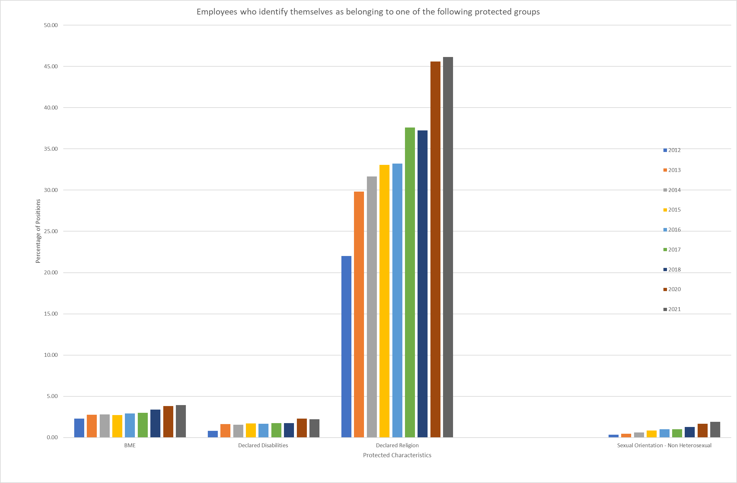

Numbers across 3 out of 4 of these protected characteristics have increased since 2018, continuing the upward trend. There is a slight reduction on those declaring a disability in 2021. There has been an increase in the workforce since 2018, and steps have been taken to improve the data capture across the equality groups. Therefore, the increases may reflect both the success of recruitment and engagement activity to improve diversity and inclusivity, and the improvements in the quality of the data.

1. **Graph – Employees Age Profile:**

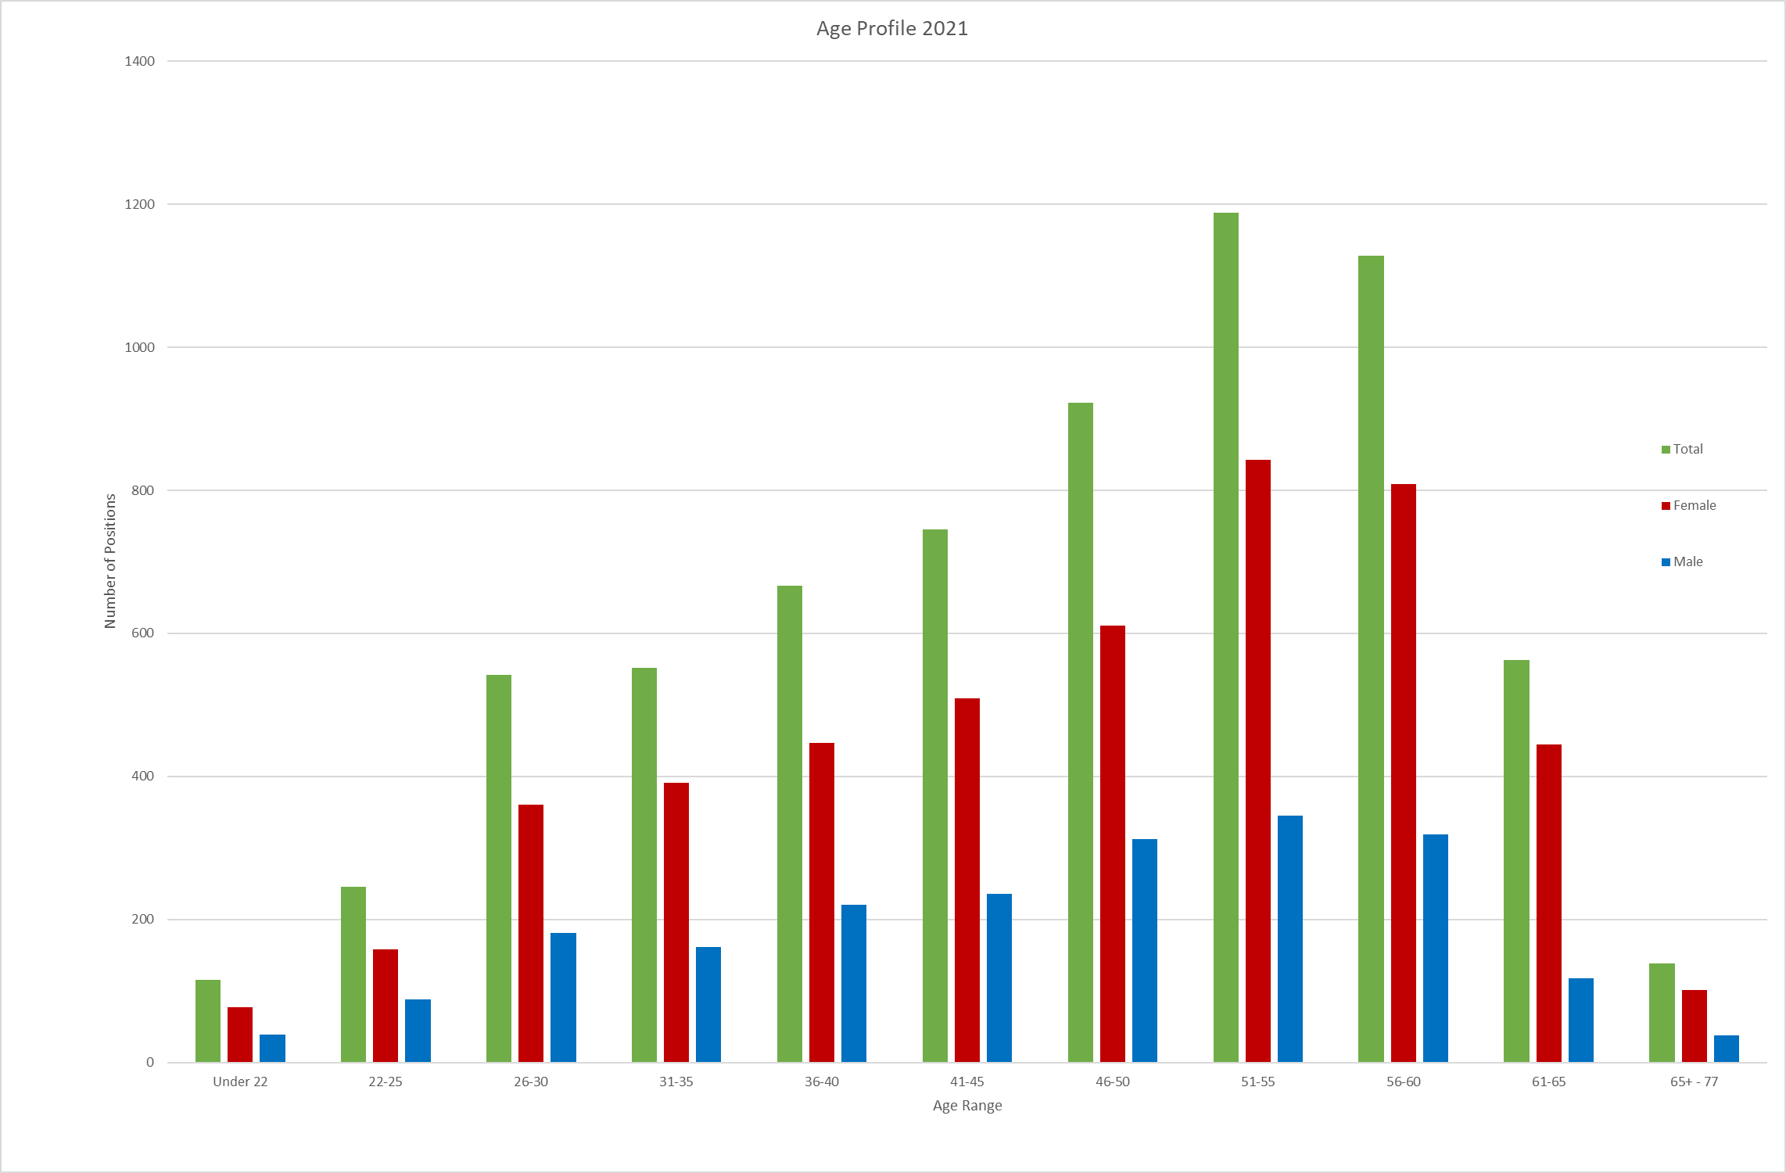

The majority of the workforce is in the 41-60 age groups with a significant proportion in the 56+ age groups. The Council employs people over the age of 65 up to age 77.

1. **Table – Number of Female and Male employees across the Age Ranges:**



1. **Graph – Age Profile Trends:**

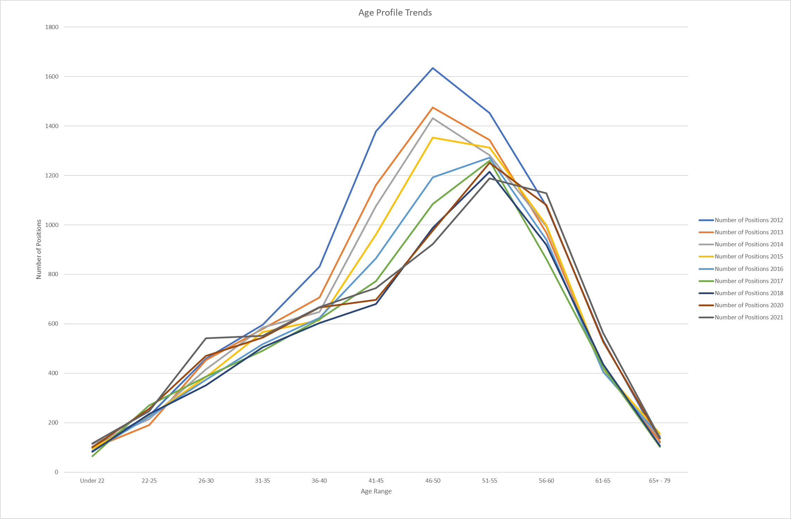

The brown and dark grey lines, which represents 2020 and 2021 shows a continuing trend towards an older workforce.

1. **Graph – Tracking Gender Trends:**

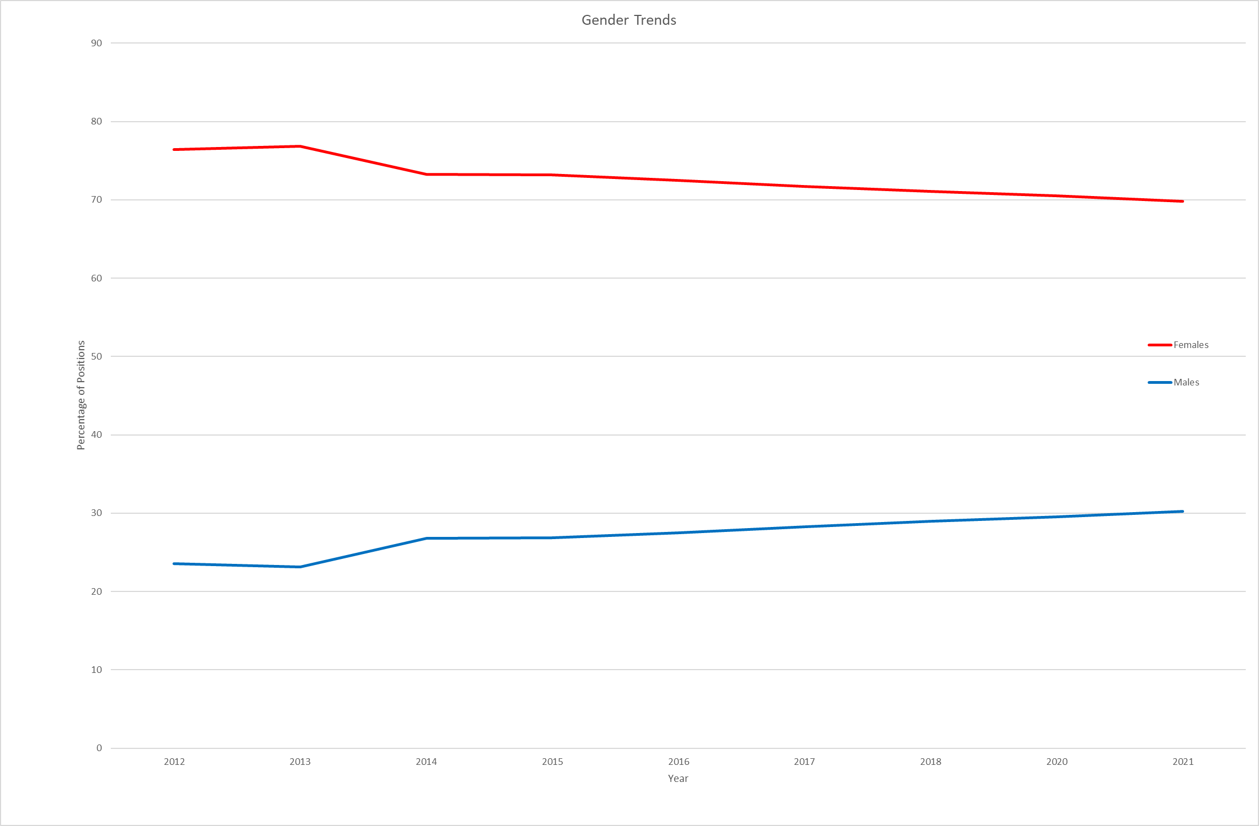The number of males has slightly increased whilst the number of females has slightly decreased, and this trend continues.

1. **Table – Numbers who have left through Dismissal, Redundancy or Early Retirement in the last 5 years:**



The highlighted areas show numbers which exceed the overall percentage of the workforce. This may need further investigation / monitoring.

1. **Table – Number of employees purchasing additional Annual Leave**

|  |  |  |  |  |  |
| --- | --- | --- | --- | --- | --- |
| 2016/17 - Total = 243 | | | | | |
|  | Gender | Ethnic Minority Groups | Disability | Religion | Sexual orientation |
| Male | 42 | 1 | 1 | 14 | 0 |
| Female | 201 | 6 | 3 | 86 | 1 |
|  |  |  |  |  |  |
|  |  |  |  |  |  |
| 2017/18 - Total = 273 | | | | | |
|  | Gender | Ethnic Minority Groups | Disability | Religion | Sexual orientation |
| Male | 50 | 1 | 2 | 13 | 0 |
| Female | 223 | 6 | 3 | 94 | 2 |

|  |  |  |  |  |  |
| --- | --- | --- | --- | --- | --- |
| 2018 - Total = 184 | | | | | |
|  | Gender | Ethnic Minority Groups | Disability | Religion | Sexual orientation |
| Male | 31 | 1 | 1 | 6 | 0 |
| Female | 153 | 3 | 2 | 78 | 0 |

|  |  |  |  |  |  |
| --- | --- | --- | --- | --- | --- |
| 2020 - Total = 213 | | | | | |
|  | Gender | Ethnic Minority Groups | Disability | Religion | Sexual orientation |
| Male | 48 | 1 | 1 | 21 | 0 |
| Female | 165 | 3 | 6 | 84 | 0 |

|  |  |  |  |  |  |
| --- | --- | --- | --- | --- | --- |
| 2021 - Total = 147 | | | | | |
|  | Gender | Ethnic Minority Groups | Disability | Religion | Sexual orientation |
| Male | 30 | 0 | 0 | 15 | 0 |
| Female | 117 | 4 | 5 | 70 | 2 |

Figures show that this option (one of the many options for more flexible working) is accessible.

1. **Table -** **Pay Gaps**

The following figures have been calculated in accordance with the government’s Gender Pay Reporting guidelines using March snapshot data. Only the Gender Pay Gap has been reported and published.

**2018:**

|  |  |  |  |  |  |
| --- | --- | --- | --- | --- | --- |
| (Hourly Rates) | Gender  (Expressed as % less than male pay) | Ethnic Minority Groups  (Expressed as a % of the non BME workforce average) | Disability  (Expressed as a % of the non-Disabled workforce average) | Religion / Belief  (Expressed as a % of the remaining workforce average) | LGBTQ+  (Expressed as a % of the non-LGBT workforce average) |
| Mean  (Average) | 13.07% | -1.42% | -10.80% | -10.40% | -7.75% |
| Median  (Mid-Point) | 25.52% | 15.66% | -14.63% | -24.05% | -14.38% |
| Bonus Mean  (Average) | -334.99% | -113.34% | -132.92% | -63.78% | 40.38% |
| Bonus Median  (Mid-Point) | -229.77% | 0% | -8.48% | 0% | 0% |

A negative figure shows that there is no gap i.e. pay is more favourable.

|  |  |  |  |  |  |
| --- | --- | --- | --- | --- | --- |
| (Hourly Rates) | Gender  (Expressed as a % of male pay) | Ethnic Minority Groups  (Expressed as a % of the non BME workforce average) | Disability  (Expressed as a % of the non-Disabled workforce average) | Religion / Belief  (Expressed as a % of the remaining workforce average) | LGBTQ+  (Expressed as a % of the non-LGBT workforce average) |
| Mean  (Average) | 9.60% | 2.72% | -7.00% | -9.72% | -8.02% |
| Median  (Mid-Point) | 18.19% | 15.86% | -10.81% | -23.00% | -9.91% |
| Bonus Mean  (Average) | -219.11% | -534.07% | -38.13% | -55.87% | 50.04% |
| Bonus Median  (Mid-Point) | -20.10 | -822.44% | -84.49% | 0.00% | 25.00% |

**2020:**

|  |  |  |  |  |  |
| --- | --- | --- | --- | --- | --- |
| (Hourly Rates) | Gender  (Expressed as a % of male pay) | Ethnic Minority Groups  (Expressed as a % of the non BME workforce average) | Disability  (Expressed as a % of the non-Disabled workforce average) | Religion / Belief  (Expressed as a % of the remaining workforce average) | LGBTQ+  (Expressed as a % of the non-LGBT workforce average) |
| Mean  (Average) | 9.39% | 2.96% | -9.44% | -8.36% | -3.50% |
| Median  (Mid-Point) | 17.62 | 17.26% | -10.31% | -23.67% | 0.00% |
| Bonus Mean  (Average) | -152.84% | -501.40% | -78.90% | -42.10% | 45.44% |
| Bonus Median  (Mid-Point) | -101.41% | -370.96% | -16.34% | 0.00% | 4.00% |

**2021:**

1. **Graph – Pay Gap Trends**

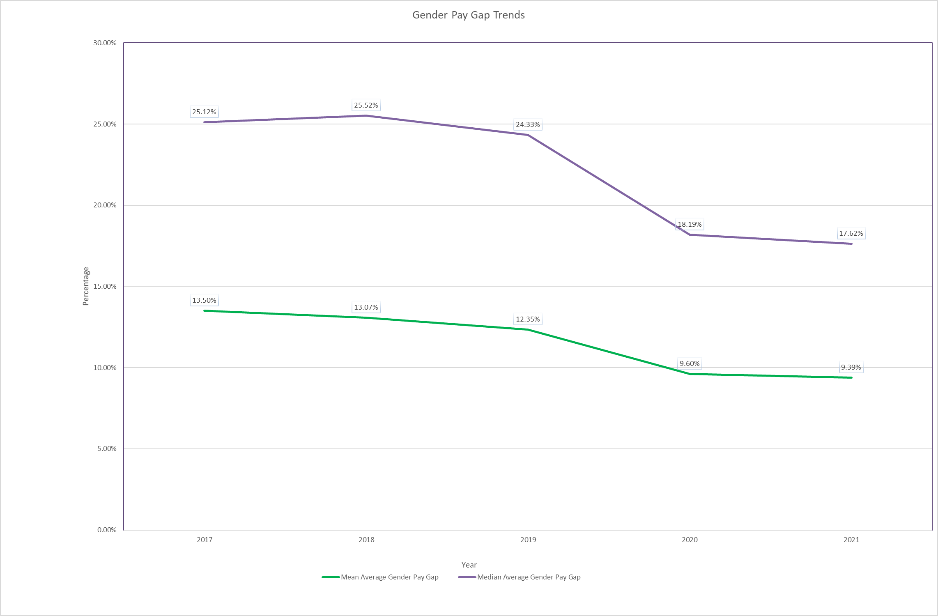

The Gender Pay Gap has been reducing since 2018.

1. **Different categories and number of learner completions per category**

|  |  |  |  |  |
| --- | --- | --- | --- | --- |
| **Ref** | **Category** | **Example course title** | **Number of courses available in category** | **Total number of course Completions**  **Per category** |
| 1 | Apprenticeships | BA (Hons) Business Management (Chartered Manager Degree Apprenticeship) | 13 | 383 |
| 2 | Coaching and Supporting Others | Coaching Champions | 23 | 481 |
| 3 | Cumbria Care | Level 2 Award in Personal Safety, Lone Working and De-escalation | 67 | 15140 |
| 4 | Cumbria Fire and Rescue | Emergency Response Driver Training (ERDT) | 51 | 560 |
| 5 | Developing and Managing People | Person Centred Absence Approach – Stakeholder Workshops | 90 | 1425 |
| 6 | Developmental Learning | Interview skills | 72 | 3425 |
| 7 | Essential Learning for All | Equality and Diversity | 10 | 38483 |
| 8 | Essential Learning Role Specific | Infection Control for Community Based Services | 70 | 5633 |
| 9 | Highways Transport and Fleet | City and Guilds Level 3 Award in Requirements for Electrical Installations 2382-18 | 66 | 931 |
| 10 | Induction | Corporate Induction | 11 | 3174 |
| 11 | Members | Code of Conduct, Equality and Ethical Standards | 6 | 189 |
| 12 | My Health and Safety | Managing Safely at Cumbria County Council (IOSH) | 31 | 6962 |
| 13 | My Health and Wellbeing | Wellbeing, Resilience and Managing Stress | 19 | 3944 |
| 14 | Safeguarding | Dignity and Respect | 12 | 14568 |
| 15 | Safeguarding Adults | Safeguarding Adults Basic Awareness | 10 | 1376 |
| 16 | Safeguarding Children | Hearing the Voice of the Child | 37 | 19 |
| 17 | Social Work | Anti-racism perspectives and approaches | 55 | 2576 |
| 18 | Wellbeing and Coaching Support Network | Wellbeing and Coaching Support Network | 13 | 406 |
|  | **Grand Total** |  | **656** | **99675** |