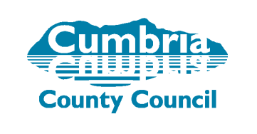
VIP: Team Themes

The team theme process allows team managers the opportunity to “feed up” feedback on their team’s performance so that senior managers, ADs and DMTs can understand the strengths within the team and consider any appropriate actions needed to support emerging themes within services.

Process:

- Managers should aim to complete all of their team’s appraisals within a rolling 12 months.
- When all appraisals are completed managers complete the Team Theme template below to identify any emerging themes or development requirements relevant to the overall performance of the team.
- Once completed, the Team Theme template is forwarded to their senior manager.
- The senior manager will take any appropriate action to support any priority needs for their teams. They will discuss the themes and support needed with the Assistant Director for the service.
- Every year, DMTs will review any emerging themes arising across their service areas. These themes will be used to inform and agree any appropriate actions needed to support the workforce in their areas.

Valuing Individuals and Performance: Team Themes
Summary Feedback Form
Team Name |  | Managers Name
Service Area: |  | Managers Role
Date: |  | Senior Manager (if different)
Main Team Successes over the last 12 months: |  | Themes: Areas of Strength (knowledge, skills, behaviours):
Themes: Collective areas for team development |  | Follow up Actions required / Proposals:
Themes: Summary of Team Wellbeing and Resilience: |  | Follow up Actions required / Proposals:
Themes: Overall motivation / Engagement / general feeling within the team: |  | Follow up Actions required / Proposals:
Themes relating to: challenges / barriers or obstacles reported |  | Are there any follow up actions required?
Once completed, this form should be submitted to your Senior Manager.

