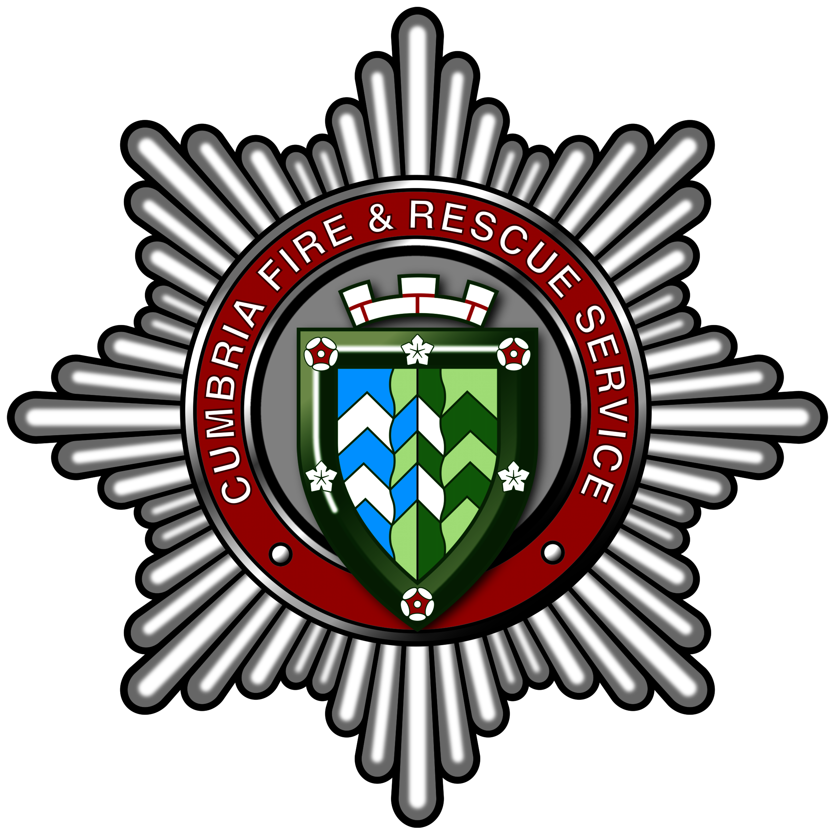
EMPLOYEE NOTIFICATION OF MATERNITY LEAVE & PAY

Cumbria Fire and Rescue Service Employees

EMPLOYEE INFORMATION
Surname: | Forename(s)
Directorate and Unit: | Place of Work/Base:
Occupation | No. of Hours worked per week:
Home Address:

Personal No: (see Payslip) | N.I No: (see Payslip)
Date Continuous Service commenced  in Local Government: | Date Continuous Service commenced  with Cumbria Fire and Rescue:
Expected date of childbirth:  (please attach original of the MAT B1 certificate confirming this and keep a copy for your own records) | Intended date of commencing maternity leave:  (NB: at least 28 days notice must be given to qualify for maternity leave and pay)
MATERNITY LEAVE
All employees are entitled to 26 weeks Ordinary Maternity Leave (OML) and 26 weeks Additional Maternity Leave (AML), giving 52 weeks in total. Qualifying employees are also entitled to 39 weeks Statutory Maternity Pay. It is up to each employee to decide how many weeks maternity leave they wish to take (the minimum is 2 weeks, the maximum is 52 weeks).

I intend to take weeks maternity leave

I understand that:

- I will receive a letter indicating my entitlement and the date on which I am expected to return to work
- It will be assumed that I am taking the number of weeks indicated above unless I give 7 days notice (if returning from OML) or 21 days notice (if returning from AML) in writing of an earlier return date.

OCCUPATIONAL MATERNITY PAY
Qualifying employees are entitled to Occupational Maternity Pay, which is an amount equivalent to 26 weeks of full pay. Employees should check the ‘Summary of Entitlements’ in the Maternity Scheme.

If you are in receipt of Childcare Vouchers through a salary sacrifice scheme this could impact on the amount of maternity pay which you receive. To ensure changes are made prior to the qualifying week, the HR, Payroll and Recruitment Administration team must be informed, where possible, of any amendments or cancellations by the 17th week of pregnancy.

I understand my entitlement to Occupational Maternity Pay. I understand that one of the qualifying conditions is that I must return to work for a minimum period of 3 months, or the gross amount must be repaid. I understand that I can defer the payment of OMP at this stage if I am unsure whether or not I will be returning to work.

YES / NO / UNSURE
I intend return to work (delete as applicable):

Employees who have confirmed that they are returning to work should complete the following section:
I wish to receive Occupational Maternity Pay as indicated:
26 weeks full pay |  |  | Lump sum on return
POTENTIAL CHANGE TO WORKING ARRANGEMENTS
I understand that I am able to request a change to my working arrangements, to take effect when I return from maternity leave and I should raise this with my Manager as soon as possible. At this stage, my interest is indicated as below:

YES / NO
I wish to consider changing my working arrangements when I return from maternity leave (delete as applicable):

I understand that my answer is not binding and I can change my mind at a later date.
APPLICANT DECLARATION
I declare that the details given above are correct to the best of my knowledge. I understand that knowingly making a false declaration is a serious disciplinary matter, which could result in dismissal. I consent to Cumbria Fire and Rescue Service processing, by means of a computer database or otherwise, any information which I provide to them for the purpose of maternity monitoring or statistical returns.
Signed: |  | Date:
MANAGER’S SIGNATURE |  | HR ADMINISTRATION
I have checked and noted the information provided. |  | Received by HR Administration.
Signed: |  | Signed:
Print Name: |  | Print Name:
Date: |  | Date:
PAYROLL
Received in Payroll.
Signed: |  | Date:

Send the completed form to the HR, Payroll and Recruitment Administration team using the HR, Payroll and Recruitment Administration Portal (http://servicecentre.ccc).

CRM Number:

