# SLT Reshaping

**Statement of Change**

05 June 2025

**To: All staff within the scope of the change**

**TU representatives**

1. **Statement of Change – Consultation Document**

1.1 This statement of change contains a proposal which will result in **a change to roles** and disestablishment of existing vacant posts. It seeks to clarify the process that will be followed for individuals who may be affected (at risk of redundancy) by the proposal to restructure the Service Leadership Team (SLT).

**2. Background**

2.1 The current SLT structure has been in place for a number of years. Generally, it reflects the roles and responsibilities assigned to individuals when the service was part of the county council.

2.2 The principal officer (brigade manager) team comprises chief fire officer, deputy chief fire officer and assistant chief fire officer.

2.3 Prior to local government reorganisation and subsequent transfer of governance of the service to Cumbria Commissioner Fire and Rescue Authority (PFCC) on 1 April 2023, the Business Manager was temporarily appointed to Programme Manager (Transition) and the Fire Strategy and Reform Manager was temporarily appointed to Head of Safety and Assurance.

2.4 The temporary appointments were introduced primarily to assist the service’s disaggregation from the county council and transition of governance to the PFCC. The appointments were for a fixed term to 31 March 2025.

2.5 The business manager and fire strategy and reform manager posts were not backfilled.

2.6 Furthermore, a head of people and talent post was created to provide strategic leadership for the HR functions previously provided by the county council.

**3. What is the Process**

3.1 The process will follow the Service’s Managing Change Procedure [managing_change_procedure_and_guidance.docx](https://view.officeapps.live.com/op/view.aspx?src=https%3A%2F%2Fwww.cumbriafire.gov.uk%2Fsites%2Fdefault%2Ffiles%2F2023-04%2Fmanaging_change_procedure_and_guidance.docx&wdOrigin=BROWSELINK) . Although it is not anticipated that this change will result in any redundancies, the service will comply with the duty to consult as a result of this reshaping process.

**4. Engagement**

4.1 There will be a 30 day engagement period for all staff in scope of the review. An initial face to face briefing will begin the process, setting out the proposals and engagement process. There will be an opportunity to ask questions of the HR Manager, Trade Unions representatives also invited to support staff.

4.2 The Statement of Change will be made available to all staff and additional FAQs relating to the service proposals will be posted on the Employee Information Website <https://www.cumbriafire.gov.uk/managing-change-reshaping-and-internal-consultations>. These will be regularly updated to reflect questions raised during the engagement process.

4.3 Engagement opportunities will be tailored to the specific needs of the service and employees in scope. They can consist of drop-in sessions, one to one meetings and a further group meeting at the mid-point. A final group meeting with those affected will be held following the closure of the engagement period, once all feedback has been considered and final decisions have been made.

**5. Trade Unions**

5.1 The Service is committed to work closely with Trade Union colleagues through this period of significant and sensitive change. Trade Union representatives will be briefed at various stages of the process ahead of communications with affected employees;

5.3 Trade Union representatives will also be invited to attend all engagement meetings with staff. There will be the opportunity at the end of the engagement meetings for Trade Unions to have initial discussion with their members. Trade Unions can also accompany their members to one to one and appeal meetings.

**6. Review, Decision and Outcome**

6.1 We will aim to notify all in scope employees of the outcome within 1 week of the engagement process ending. This will be accompanied by an outline timetable for the process.

6.2 Should there be a need to extend the 1 week decision period as a result of significant issues raised, then all staff will be notified as early as possible, with an explanation for why an extension is required.

**7. Assimilation Processes**

7.1 The full details of the assimilation process are contained in the Reshaping Guidance document.Whilst engagement is taking place it is important that all ‘in scope’ employees examine their current role profile to ensure it accurately reflects the reality of their substantive role. Amendments to job descriptions will only be accepted with the relevant line manager agreement.

7.2 The assimilation outcomes are:

***Direct assimilation***

* Defined as where a role in the new structure is substantially similar (75% match or more) **and at the same grade.**
* Direct assimilation can only occur where there are sufficient posts available for the number of employees involved. If there are fewer posts than employees then a competitive selection process will be required.

***Assessment assimilation***

* Defined as where a role in the new structure is substantially similar (75% match or more) **and at a different grade**.
* It is the responsibility of the employee to identify and objectively evidence that a new post is substantially similar (75% match or more), which must be verified by 2 managers (HR Manager and CFO).
* Upon verification a desktop assessment will be undertaken to ensure that the candidate for assimilation has the required level of skills, knowledge and competencies to undertake the essential duties of the new post.
* In some cases it may be necessary to use an alternative but appropriate assessment process, such as observed working, skill test or selection interview.

***Competitive selection***

* A competitive selection process is necessary for recruitment to those posts where there are more employees who meet the assimilation criteria than jobs available.
* Where competitive interviews are required for posts at the same grade but there are too many people than posts, then all posts should be filled (as would be the case in direct assimilation if there had been enough posts).
* Where competitive interviews are required for posts at different grades, then as a principle posts will be filled wherever possible (with training and development as appropriate), ensuring the capabilities and experience of the applicant meets business needs. However, this cannot guarantee all posts will be filled as business needs mean the correct candidate must demonstrate the necessary skills and experience to fulfil the role, allowing also for any reasonable up-skilling or retraiing that would assist the candidate to be appointed or develop into the post.

***No match – “At Risk”***

* Employees, who are not assimilated or appointed to posts, will be formally placed ‘at risk of redundancy’ and afforded ‘ring fenced’ status in the Vacancy Preference Process. “At Risk” is a formal term relating to redundancy.

7.3 All employees will be notified in writing of the outcome of assimilation. The outcome will confirm the assimilation decision but will not always confirm appointment to a post. In most cases this will only be confirmed once the appeal process has been completed.

7.4 All employees have the opportunity to appeal the assimilation outcome. They will have 7 calendar days to appeal the decision and will need to provide written evidence to support the reasons for the appeal.

7.5 Appeals will be considered by the CFO . They will review and consider the written appeal submissions and a meeting will be held with the appellant. The appeal decision will be final and there will be no further right of appeal.

7.6 Employees have the statutory right to be accompanied at an appeal meeting by a Trade Union representative or a work colleague.

7.7. A confidential meeting will take place with recognised Trade Unions following the

assimilation process and before the outcomes are shared with staff. Trade Unions will

have the ability to look at a selection of assimilation outcomes to scrutinise and challenge

the assimilation process in more detail, with the ability for meaningful changes to be

made where jointly agreed.

**8. Vacancy Preference Process (VPP)**

8.1 Where an employee is not assimilated into one of the posts in the new structure, they will have the opportunity to be considered for the remaining posts before they are opened up to wider competition. Employees will be provided with the details of the remaining vacancies and given the opportunity to apply.

8.2 Where employees have not been appointed to posts following VPP they will be eligible for Alternative Employment Support. All avenues will be explored to avoid the need for redundancy; however once there are no other options available then redundancy notices will be issued.

8.3 Pay protection does normally not apply to employees in existing temporary roles. The service have taken a decision to honour this should the grade of the new role be less than an existing temporary post. Pay protection will be paid up to a maximum of 12 months, after which time the new salary will apply.

8.4 For the Assistant Chief positions, in line with NFCC guidance the roles will be advertised on a national level. Please note the current permanent post holder is retiring from Service and therefore is unaffected.

**9. Alternative Employment Support**

9.1 Where an employee has not been appointed to a post through the reshaping, a meeting will be arranged to discuss options such as suitable alternatives, VR, and trial periods. Individual action plans will then be developed to support the employee in securing alternative employment. The plans could include attendance at interview skills workshop, financial advice support and awareness of upcoming vacancies that may be suitable to apply for.

9.2 Employees will be eligible for alternative employment support and will have regular meetings with their manager to review the individual action plan and provide ongoing support throughout the process.

9.3 Where redundancy notices are issued alternative employment support will continue to be provided and all avenues will continue to be explored to avoid the need for redundancy during the redundancy notice period.

**10. Voluntary Redundancy (VR) and Flexible Retirement**

10.1 It should be noted that any interest or application for VR will be assessed on a case by case basis in line with business needs.

**11. Scope**

11.1 The posts in scope of the proposed service review are:

| **Post Title** | **Post Grade** | **Number of Posts** | **Number of Posts FTE** |
| --- | --- | --- | --- |
| Deputy Chief Fire Officer (current vacant post) | Gold Book | 1 | 1 |
| Assistant Chief Fire Officer (Permanent) | Gold Book | 1 | 1 |
| Assistant Chief Fire Officer (Temporary) | Gold Book | 1 | 1 |
| Fire Strategy and Reform Manager (substantive) | 17 | 1 | 1 |
| Business Manager (Substantive) | 17 | 1 | 1 |
| Head of People & Talent (current vacant post) | 18 | 1 | 1 |
| **Total** |  | **6** | **6** |

**12. Future Structure and Staffing Proposals**

12.1 The current and the new proposed structure can be found in **Appendices 1.**

12.2 The proposed new structure for consultation will consist of:

| **Post Title** | **Post Grade** | **Number of Posts** | **Number of Posts FTE** |
| --- | --- | --- | --- |
| Assistant Chief Fire Officer – Service Delivery | Gold Book | 1 | 1 |
| Assistant Chief Fire Officer – Service Support | Gold Book | 1 | 1 |
| Head of Programme & Risk |  | 1 | 1 |
| Head of Planning & Improvement |  | 1 | 1 |
|  |  |  |  |
| **Total** |  | **4** | **4** |

12.3 If agreed following consultation, this would result in:

* A reduction by 1 FTE to the overall FTE of SLT. The Head of People & Talent will not be replaced. The current vacant Deputy Chief Fire Officer will be removed from the structure instead being replaced by two permanent Assistant Chief Fire Officers.
* The proposal will result in savings of £158k. Savings are generated from the disestablishment of the deputy chief fire officer post, the disestablishment of the head of people and talent post (£90k); the disestablishment of the equality, diversity and inclusion officer post (£63k). Equality, diversity and inclusion (EDI) will become a shared and collective responsibility of SLT with the assistant chief fire officers leading on (EDI) for their respective service delivery and service support functions. Note: salary costs are inclusive of on costs and include the 2025/26 anticipated pay award.

**13. Approach for the establishment of the proposed structure**

* 1. The proposed timeline for the review is set out in the attached Appendix 3.

**14. How to engage with the reshaping proposals**

14.1 All consultation and supporting information will be made available on the Employee Information Website following the first staff consultation meeting. An electronic information pack will also be made available.

14.2 Communication methods and information will be available in a range of formats where required to ensure equal access to the documentation for all employees.

14.3 All employees in scope of the reshaping will be offered at least, one 1:1 meeting during the reshaping process. The purpose of this is to seek the views and ideas of staff in relation to the proposals and provide as much opportunity for personal circumstances to be listened to, collated and considered.

14.4 To request a 1-2-1 or group meeting with management, please contact Jemma Taylor / Helen Clark (HR Manager job share) [jemma.taylor@cumbriafire.gov.uk](mailto:jemma.taylor@cumbriafire.gov.uk) [helen.clark@cumbriafire.gov.uk](mailto:helen.clark@cumbriafire.gov.uk) .

14.5 Members of the recognised Trade Unions may wish to give their feedback through their Trade Union representative.

**15. Timescales**

* 1. The proposed timeline for the review is set out in the attached **Appendix 3.**
  2. I hope that I have covered as much as I can as part of this document, however if there are any queries please contact Jemma Taylor / Helen Clark (HR Manager job share) [jemma.taylor@cumbriafire.gov.uk](mailto:jemma.taylor@cumbriafire.gov.uk) [helen.clark@cumbriafire.gov.uk](mailto:helen.clark@cumbriafire.gov.uk)

**Appendices**

Appendix 1 Current structure

Appendix 2 Proposed structure

Appendix 3 Timeline

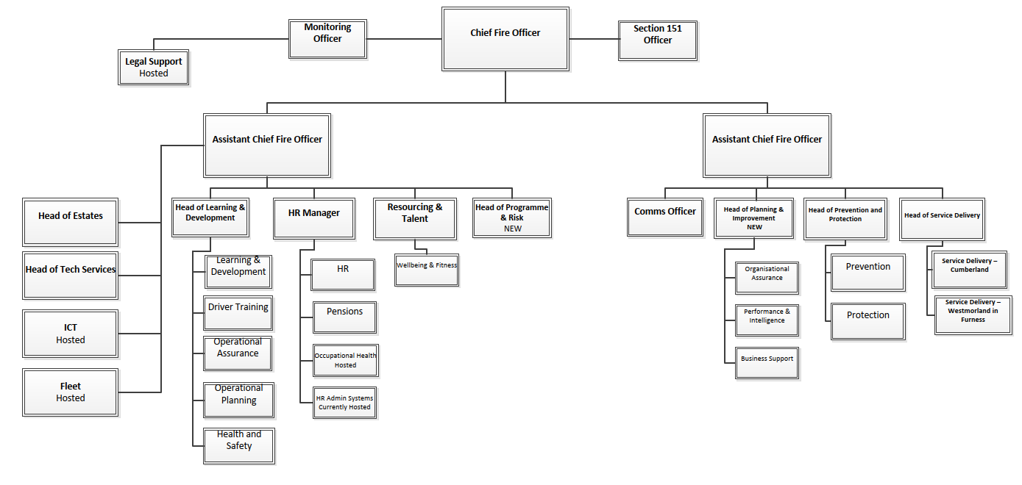

**Appendix 3 - Timetable**

|  |  |
| --- | --- |
| **DATE/S** | **ACTIVITY** |
| ***Phase 1 - Information exchange/engagement*** | |
|  | Meeting with Trades Unions ahead of the start of engagement |
|  | **Meeting with staff in scope** (Trade Unions invited)  **Consultation process starts**  Wednesday 7th May, Kemplay Bank Mtg Room HQ 12.30 – 14.00 |
| As required | Individual meetings available upon request One to Ones- Employees can be accompanied by Trade Union |
|  | **Mid-Point staff meeting** (Trade Unions Invited)  Wednesday 4th June, Control Room HQ 12.30 – 13.30 |
|  | **Consultation process closes** |
| ***Phase 2 - Decision*** | |
|  | Collation and review of feedback from staff and Trades Unions and reflection of structure proposal. |
|  | **Final Decision Staff meeting** (Trade Unions Invited)   * Final structure released   Thursday 19th June, Control Room HQ 13.30 – 14.30 |
| ***Phase 3 - Implementation*** | |
|  | * Meeting with Trade Unions to review Assimilation Outcomes * Assimilation outcomes confirmed * Assimilation appeals * Assimilation appointments confirmed * Vacancy Preference Process * Interviews * Where applicable redundancy notices issued |
|  | Transition to new structure |