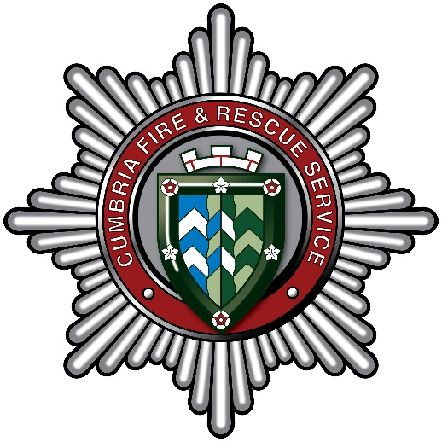
Trainee Accounting Technician
Overview of Career Grade Scheme
Department: | Corporate Services | Service: | Finance
Responsible to: | Financial Accountant | Responsible for: | N/A
Grade: | Career Grade Role progressing from  - Finance Administrator (Grade 6) through grades 7 and 8 to  - Accounting Technician (Grade 9) – Final Grade
Location: | Carlisle East Fire Station (with some working from Penrith Fire HQ)
Cumbria Fire & Rescue Service (CFRS) is now the responsibility of the Office of the Police, Fire and Crime Commissioner.
The Cumbria Fire & Rescue Service Finance team is part Corporate Services department.
The team is responsible for providing support to front line Fire service through a mixture of technical, operational and strategic advice. This support ensures that managers across the service can effectively manage their budgets, make effective decisions and develop and deliver change projects. The support also ensures that the financial systems and the subsequent accounting information is robust. In particular the team lead on providing both revenue and capital budget support to managers, developing the annual Budget and five-year Medium Term Financial Plan, producing the annual Statement of Accounts and undertaking financial modelling to support saving proposals and change projects.

Purpose of this post
This role is planned as a Career Grade, with the entry point as a Grade 6 Finance Administrator, which will progress through further Grade 7 and Grade 8 roles, with the end point of the Career Grade Scheme as a Grade 9 Accounting Technician. This will aid resilience within the Finance team.
This role is open to all candidates who have an interest in financial matters and are eager to learn and develop their knowledge and skills by working towards the AAT qualification. This opportunity could be for someone who may be at the start of their career, as full training and development will be given to progress to the final Career Grade point.
The development plan will assist in guiding the successful candidate through the process of learning about the Cumbria Fire and Rescue service, it’s strategies and plans and developing initially entry level knowledge skills in relation to financial systems and processes; and then building on these skills whilst undertaking a supported training qualification as an accounting technician.
As the successful candidate progresses through both the qualification, which has 3 distinct levels, they will be assisted to layer up their initial knowledge and skills through on the job learning and development to be able to provide flexible and professional support to other finance colleagues and the service as a whole.

Key terms and conditions of the Career Grade Scheme
The successful candidate will be required to:

- Undertake all training and development opportunities in order to gain the qualifications, skills, and competencies required to progress to the next level.
- Compile a Personal Development Portfolio of evidence achieved (this will be supported by the wider team).
- Complete, with line manager, the Career Grade Assessment Record
- Attend regular reviews and appraisals
- Agree to the Career Grade Training Agreement
Full information and guidance will be provided on successful appointment.
Key Tasks & Responsibilities:
The key job specific accountabilities of each stage in the development plan will assist in guiding the successful candidate through the development process and the Post Specifications for the Grade 6 and Grade 9 posts are provided with this Development Plan.

- Entry Level - Finance Administrator – Grade 6
- Intermediate Role 1 – Grade 7
- Intermediate Role 2 – Grade 8
- Final Level - Accounting Technician – Grade 9

During each stage of the Development Plan the successful candidate will be expected to undertake other responsibilities in the finance team commensurate with the grade as directed.

Studying for AAT’s Accounting Technician Qualification
This qualification covers the diverse range of skills and expertise required of entry to mid-level Finance employees, from basic management and financial accounting skills through to applied management accounting and system support. The AAT qualification is not only globally recognised but also supports excellent career progression, with AAT members holding a variety of middle level finance and accounting positions.

AAT Level | Syllabus headings
AAT Level 2  Certificate in Accounting | Introduction to Bookkeeping  Principles of Bookkeeping Controls  Principles of Costing  The Business Environment
AAT Level 3  Diploma in Accounting | Business Awareness  Financial Accounting: Preparing Financial Statements  Management Accounting Techniques  Tax Processes for Businesses
AAT Level 4  Diploma in Professional Accounting | Applied Management Accounting  Drafting and Interpreting Financial Statements  Internal Accounting Systems and Controls  Plus 2 Optional modules (choices below):  - Business Tax  - Personal Tax  - Audit & Assurance  - Cash and Financial Management  - Credit & Debit Management

Salary and Career progression
The table below sets out the potential pathway of how the successful candidate may progress through each level of the qualification.
Progression to the next salary level will be assessed based on successful achievement of the relevant level of the AAT qualification together with their ability to demonstrate the required levels of knowledge and skills developed through on the job learning.

Stage | AAT Level | Grade | Salary range from | Salary range to
1 | Entry Level | Grade 6 | £25,584 | £25,992
2 | AAT Certificate in Accounting | Grade 7 | £27,711 | £28,624
3 | AAT Diploma in Accounting | Grade 8 | £31,067 | £31,586
4 | AAT Diploma in Professional Accounting | Grade 9 | £33,366 | £34,314

Pay scale as at March 2025.

