Occupational Health Service

Manager’s Portal Guidance

Introduction

The Occupational health system provides, in one place, a record of all employees medical records/ referrals.

eOPAS the Occupational Health system provides a :-

- portal for managers to input referrals direct (no separate word documents or need to save documentation elsewhere)

- Web based confidential recording system for all occupational health activity and medical information allowing the OHS to access individual records at all Council locations without the need for paper files.

- diary management system for clinics and appointments which can be emailed to employees and managers.

The system works using a series of forms. As a manager you will complete a medical referral form for an individual and will then receive one back from the OHS detailing the results of the medical appointment with the individual. Once a form has been “submitted” it is locked and no changes can be made. You can “save draft” if you need to pause the completion of the form whilst you get additional information. If you have pressed submit and further information comes to light you would submit another “additional information form” and link it to the person. This would be similar to the notes section in the old OHS portal. Likewise if you just had a query for the OHS you would choose an “Additional information “ form. How to do this will be described below.

Please note: Before you create any referral form you must check iTrent to make sure your employees name / address / telephone numbers are correct. If possible we would also like home email addresses. If they are incorrect then the employee won’t receive appointment letters/emails. The OHS cannot change these details as they would be overwritten by the daily export from iTrent into eOPAS.

 | Page
Getting Started | 2
Creating a medical referral | 3
Updates / Additional Information / General Queries | 5
Attachments | 7
Receiving a completed medical report | 8

Getting Started
1 | https://GenohsisPortal.cumbria.gov.uk/Portal | Managers should access the system using the link
2 | 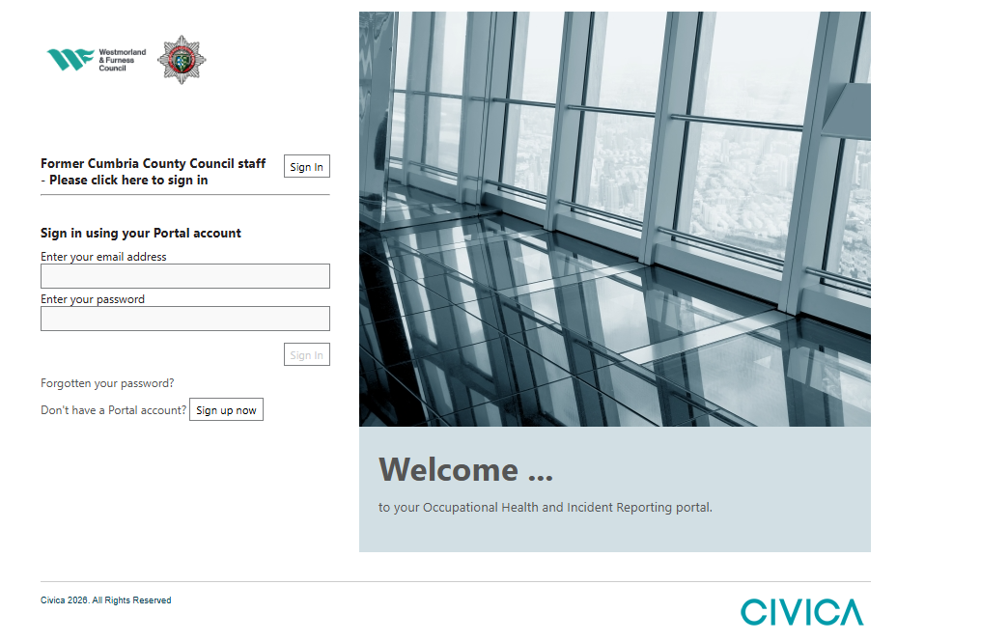 | Log in  You should log in using your normal Council log in details.  If this is the first time you log in you will receive a verification email from the system. You will need to go to that email and following the instructions.  You won’t need to do this every time you log in.  The password should contain – upper and lower case, numbers and symbols.  The company id is M500FAB8  You will also be shown a series of videos which go through the process of inputting a form.
3 | 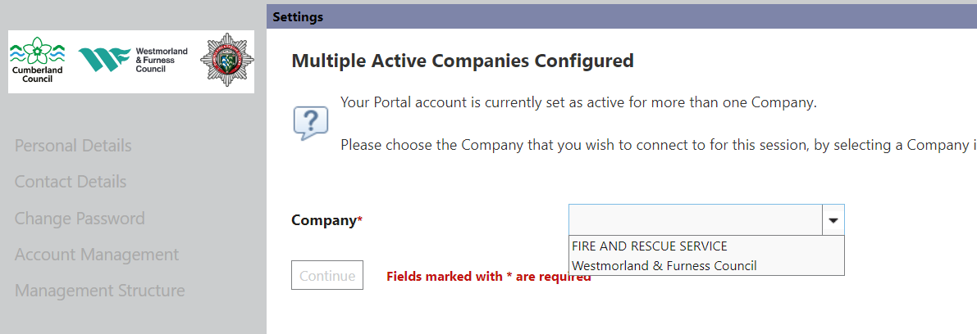 | If you are logging for a second or subsequent time you may be asked for your organisation.  Click on “Continue”  If at any time the expected pick list seems to move or not be in the correct place then you please change your zoom to between 100 and 125%. This should correct the problem.
4 | 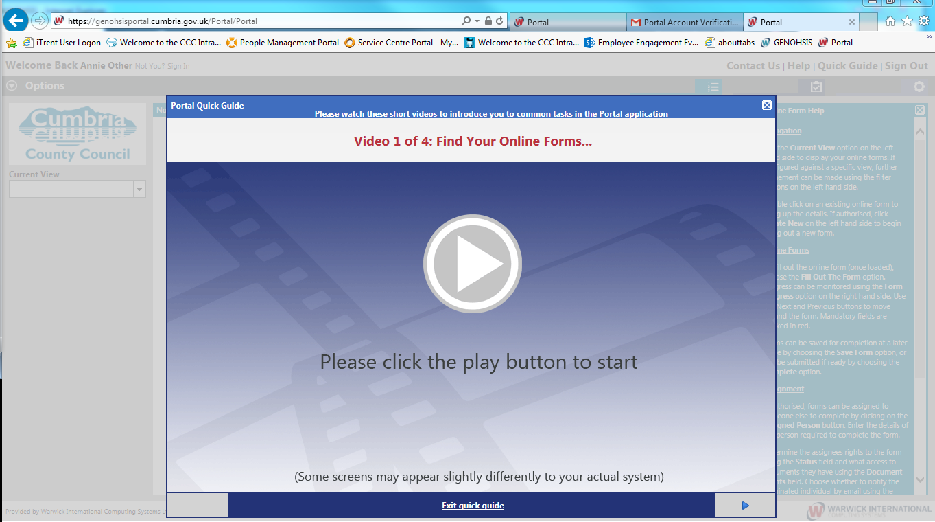 | Quick Guides  This screen then appears. If you would like to be reminded about how to input forms you can click on the Quick guide and watch the videos again.
5 | 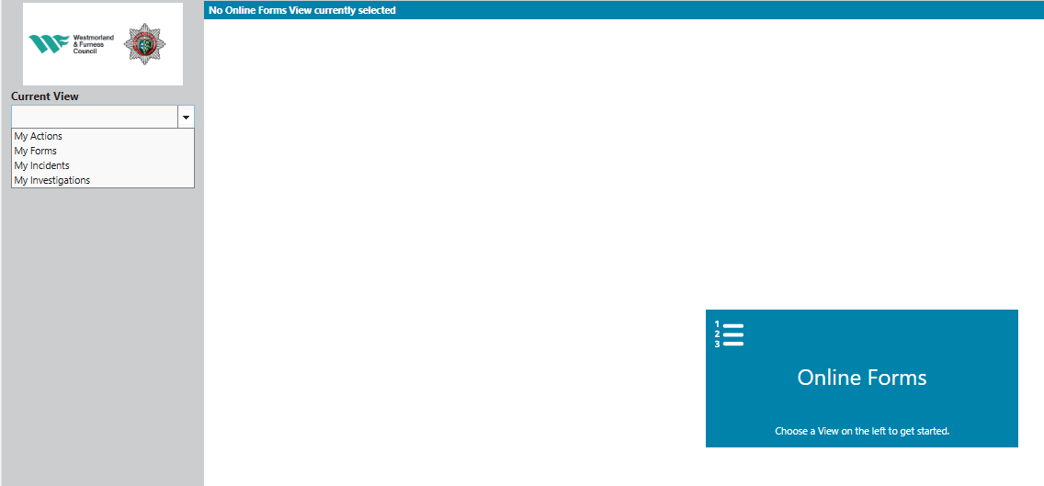 | Create a new medical referral  To create a new medical referral form click on the drop down arrow.  Choose “My Forms”  The other items in this list are concerned with eSafety and will be explained in their guidance.
.Creating a Medical Referral form
6 | 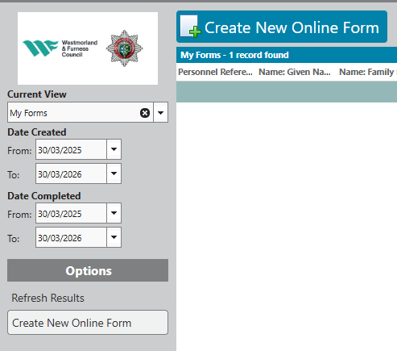 | To create a new form  Click on “Create New Online form”
7 | 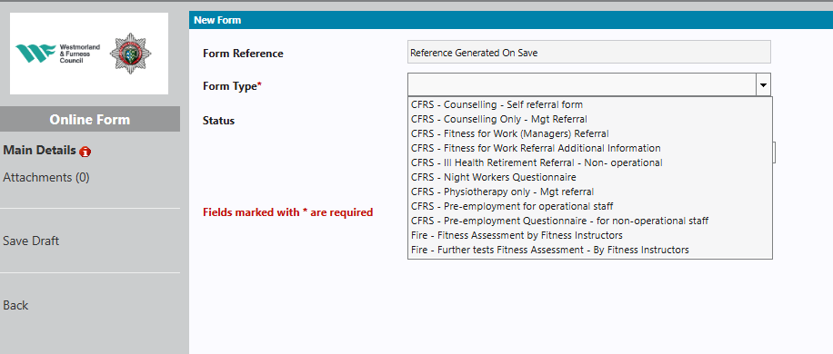 | Click on the drop down list in form type. Choose the form you need to complete.  Please ensure you select the correct form starting with CFRS  See below for a description of the different forms
8 | There are different forms available depending upon the circumstances of the case:-  Please ensure you select the forms that begin with “CFRS” and choose the correct form from the list below.  If you are unsure which form to use, or would like to confirm that we have received your referral, please contact us at: occhealth@cumbriafire.gov.uk.  Once you have chosen the form – click on continue and answer ALL the questions
  CFRS – Fitness for work referral | CFRS – Fitness for Work Referral  Use this form for new management referrals when:  - You need advice on whether an employee is fit to attend work.  - You require guidance regarding a medical condition.  You will receive a full Occupational Health report once the assessment is complete.  At the end of this form, you may also choose to refer for physiotherapy or counselling.
  CFRS – Fitness for work referral additional information | CFRS – Fitness for Work Referral: Additional Information  Select this form if:  - You have already submitted a Fitness for Work referral, and  - You need to provide further information or ask a question about the existing referral.
  CFRS – Counselling Only Mgt Referral | CFRS – Counselling Only (Management Referral)  Use this form to refer an employee for counselling only.  Please note:  - The employee will be referred solely for counselling.  - You will not receive an OH report or Occupational Health advice.
  CFRS – Physio only | CFRS – Physio Only  Use this form to refer an employee for physiotherapy only.  Please note:  - The employee will be referred solely for physiotherapy.  - You will not receive an OH report or Occupational Health advice.
  CFRS - Ill health retirement form | CFRS – Ill Health Retirement Form:  - Before completing this form, please contact People Management for guidance:  📧 HR@cumbriafire.gov.uk  - This is a referral for Ill Health Retirement
  CFRS - Ill health retirement form additional information | CFRS – Ill Health Retirement: Additional Information  Use this form if:  - You have already submitted an Ill Health Retirement form, and  - You need to provide further information.
9 | 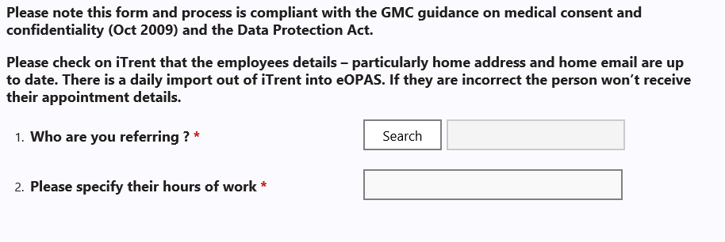 | When you are asked the question “Who are you referring?” Click on the Word Search next to it
8 | 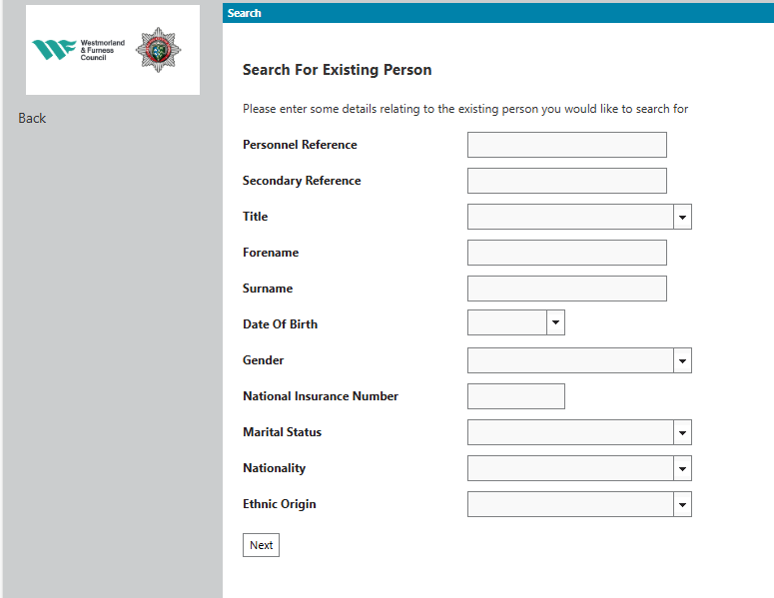 | Type the persons surname /Family name in the box  Click on “Next”  Then click on the correct person from the list. Their details will be brought through.  Complete the questions as appropriate
Please note: You must check iTrent to make sure your employees name/ address/ telephone numbers are correct. If possible we would like home email addresses. If they are incorrect then they won’t receive appointment letters/emails. The OHS cannot change these details as they would be overwritten by the daily iTrent into eOPAS.

9 | 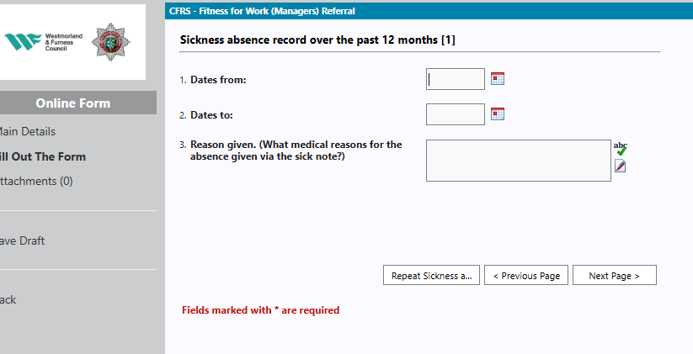 | Inputting sickness  When you get to the sickness record screen input the absence. If there is more than one absence, click on “Repeat sickness absence record” a further set of boxes appear. Repeat as necessary.  It is hopeful that at some point the sickness record will be part of the daily data load from iTrent and managers will no longer need to input the sickness record.
10 | 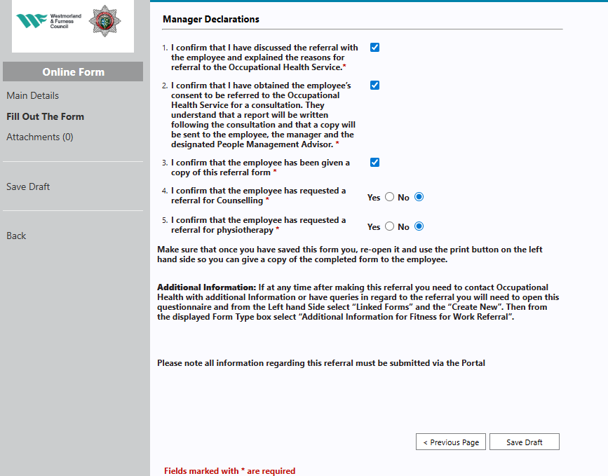 | Finish answering the questions.  Please note once you press “Submit” the form cannot be changed.  If you need further information before finishing the form click on “Save a draft”. The form will then appear in the middle section of the home screen. You can just click the form and then continue working on it.  Once you are happy with the form click on “Submit”.
The Occupational Health Service will then triage the form. You will receive an email notification of any appointments made and actions taken. Once they have seen or had a telephone consultation with the person they will send you a report. See 17 below on how to access it.

Updates / Additional Information / General Queries
If you have additional information about an individual or a general query then please use the additional
information forms, described below, rather than emailing or calling the OHS. This means there is a record attached to the individuals file and the information can be taken into account when the person is seen.

11 | 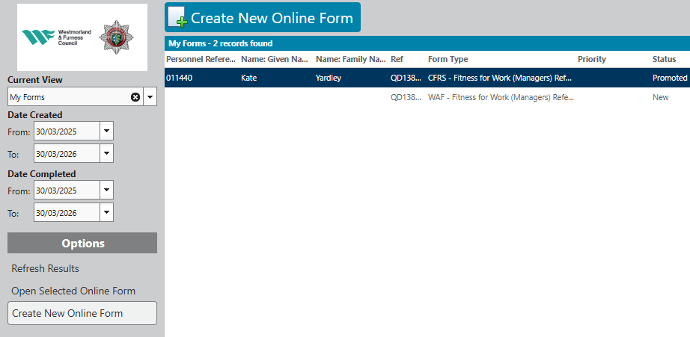 | Go into your forms and find the form of the person you want to add additional information for.  Double click so that it opens
12 | 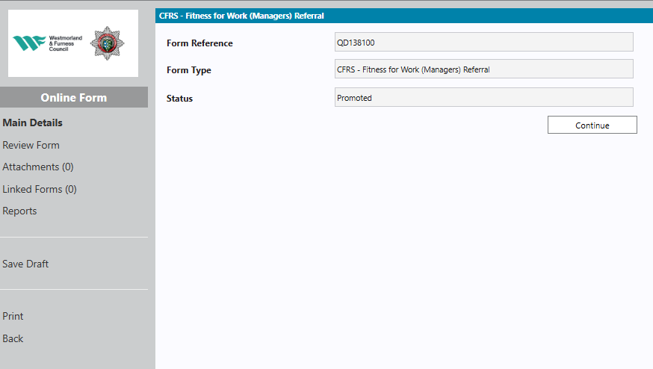 | Click on Linked forms
13 | 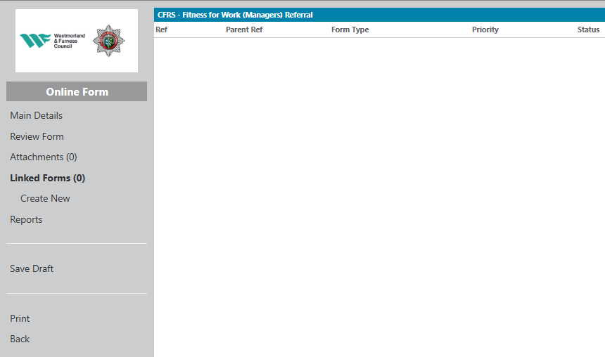 | Click on Create new

14 | 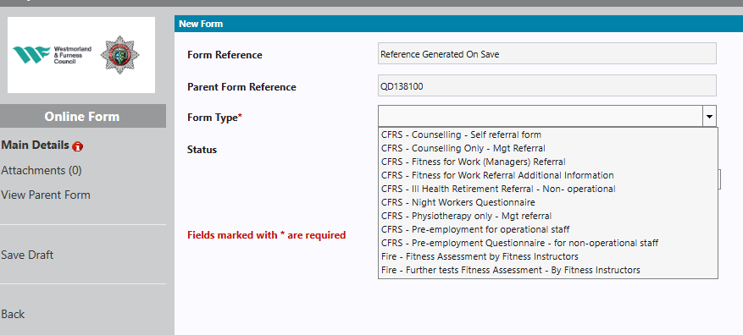 | Choose the type of form you want to add.  Usually  CFRS - Fitness for work additional information or  CFRS - Ill health retirement additional information and queries
15 | 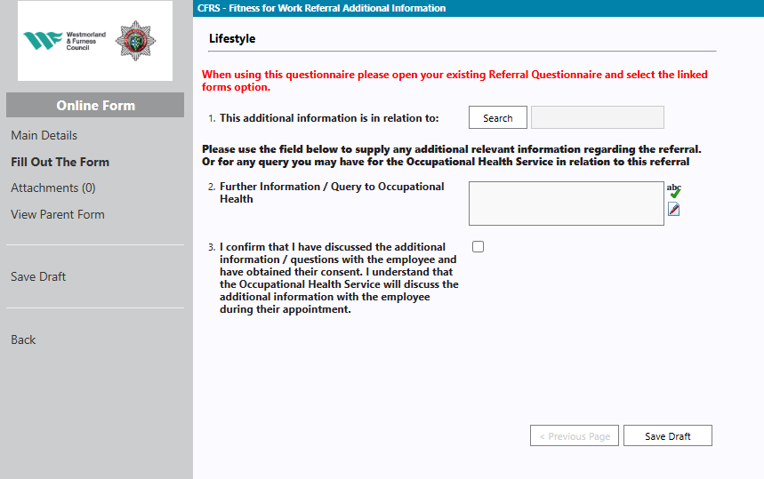 | Find the person and then complete Q2  Add in the additional information or query.  Click on Save Draft and then click on submit

Attachments

16 | 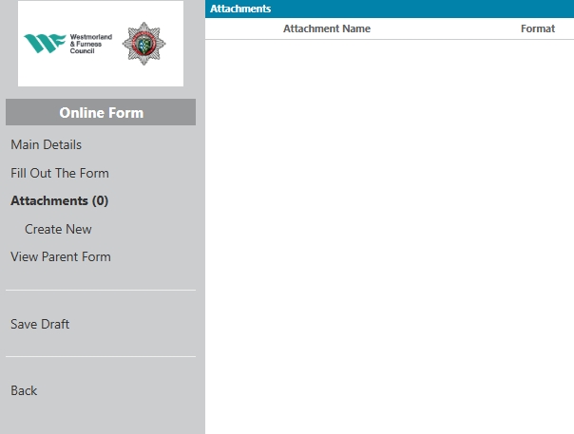 | Attachments  If you need to add additional attachments such as letters from GPs then this will need to be scanned and saved in your own documents. Attach it to the person’s record by clicking on “Attachments”.  Click on “Create New”
17 | 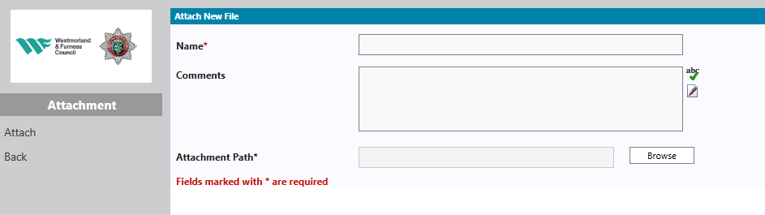 | Upload a document  Click on “Browse” and find the document you want to attach. Add in a name and comment just stating what the attachment refers to.  To add it you must then click “Attach” again. It won’t save if you don’t

.

Receiving a completed medical report

18 | 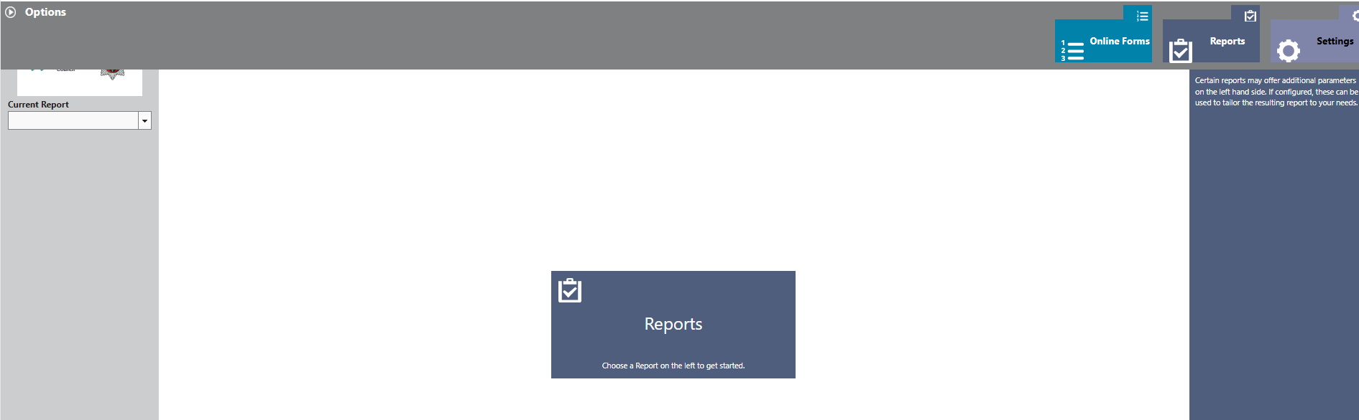 | Reports from OHS  Log in to your account as above  To view your report click on the purple reports box
19 | 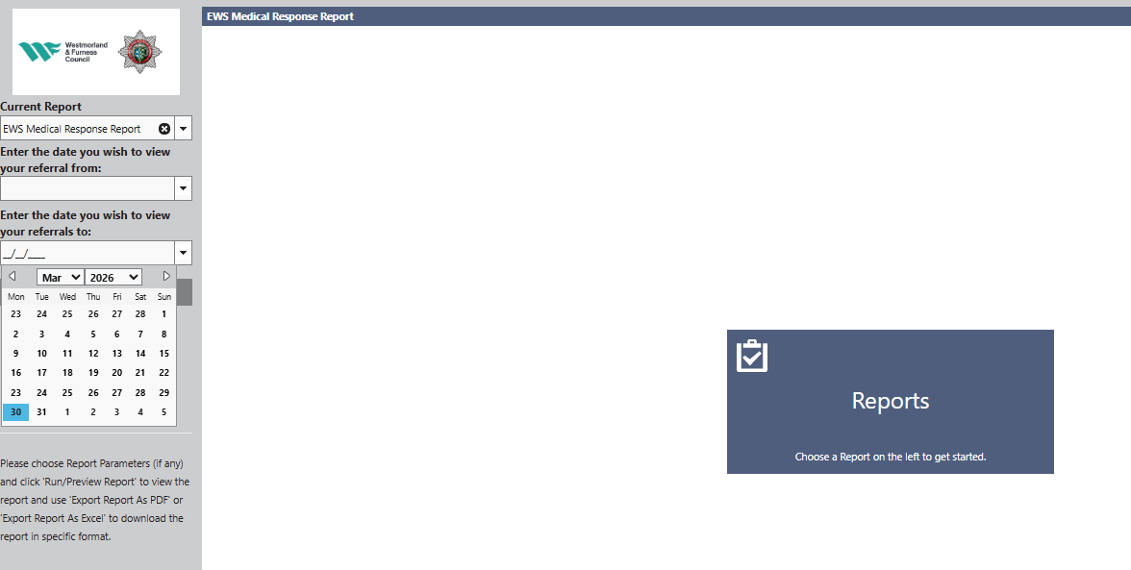 | Choose the report type in the Current report drop down.  This will normally be  OHS Medical Response Report  Put in a date range – this should include the date you made the referral otherwise they might not appear, Normally go back a year.  Click on Run/ Preview Reports  Choose the report you want to view
20 | 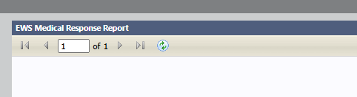 | Move across the pages using the arrows at the top.  If you need to print the report  Click on Export as PDF and then print as normal.

If you have any difficulties please call the Occupational Health Service on 01768 812600.

