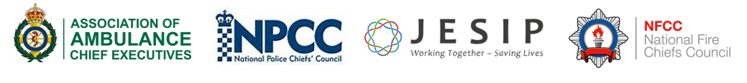

Expression of Interest

Application for the role of: | JESIP Business Support Officer

Personal details

Full Name:

Current rank / grade:

Current Employer:

Current role / Job Title:

Contact telephone number(s):

Email Address:

Geographical Location
(County / City):

Service Support

Name and Rank of individual supporting this application:

Evidence in Support of Application

In no more than 1000 words describe how your Skills, Knowledge and Abilities meet the Entry Requirements as set out in the Role Profile for the role you are expressing an interest in.

Evidence (1000 words maximum)

Please complete the expression of interest EOI form and along with a copy of you most recent CV and send to Chris.Dingle@Herts.police.uk

