L&D Department -

Operational Bulletin

Basic Fire Ground Set Up

General Description
L&D would like to extend its thanks to all ICL1 commanders who attended the BA Command Course during the 2025–26 training year for their valuable contribution to the development of this fireground setup.

The ‘initial’ fireground setup refers to the structured organisation and deployment of equipment in accordance with the tactical objectives set by the Incident Commander at fires within the built environment.

This setup is fundamental in supporting a safe, controlled, and coordinated firefighting response. It ensures that both internal and external firefighting activities can be carried out effectively, with the necessary resources in place to protect crews, maintain operational flow, and achieve the incident objectives.

It is important to note that the initial fireground setup can be developed and expanded by the Incident Commander as additional resources arrive on scene. However, the initial configuration is designed to be simple, structured, and achievable by a minimum crew of four prior to committing into the premises under rapid deployment conditions, or by a crew of three in advance of further resources arriving, enabling safe and effective initial interior commitment.

The initial fireground setups will be incorporated into the forthcoming Firefighting Tactics Foundation Document upon publication.

Any questions, please contact Station Manager Tom Harding (L&D Department).
FireService.LD@cumbriafire.gov.uk

Fire Ground Set Up – Hose Reel selected as Fire Attack
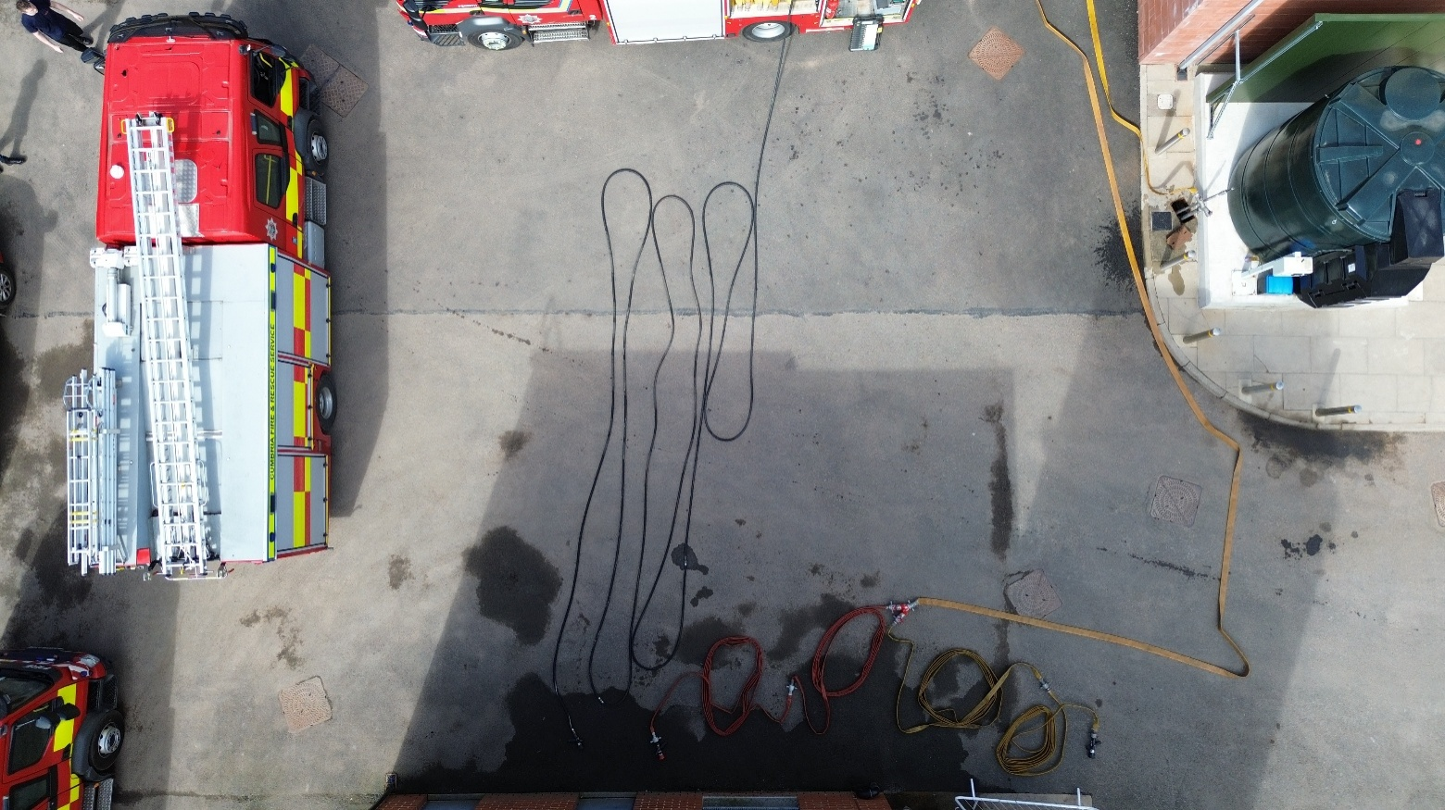
(Fig.1 – Aerial view of fire ground set up with hose reel selected as fire attack)

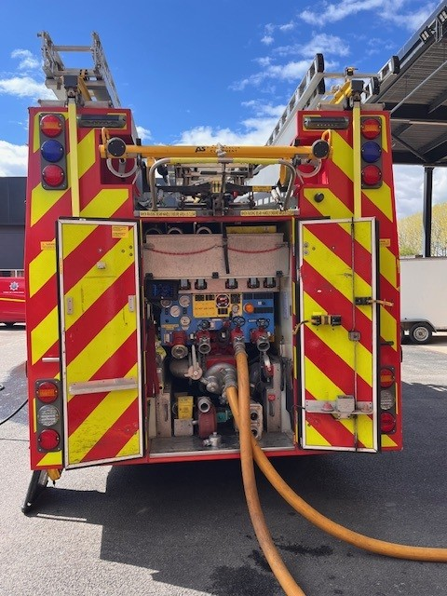
(Fig.2 – Appliance Bay view of fire ground set up with hose reel selected as fire attack)

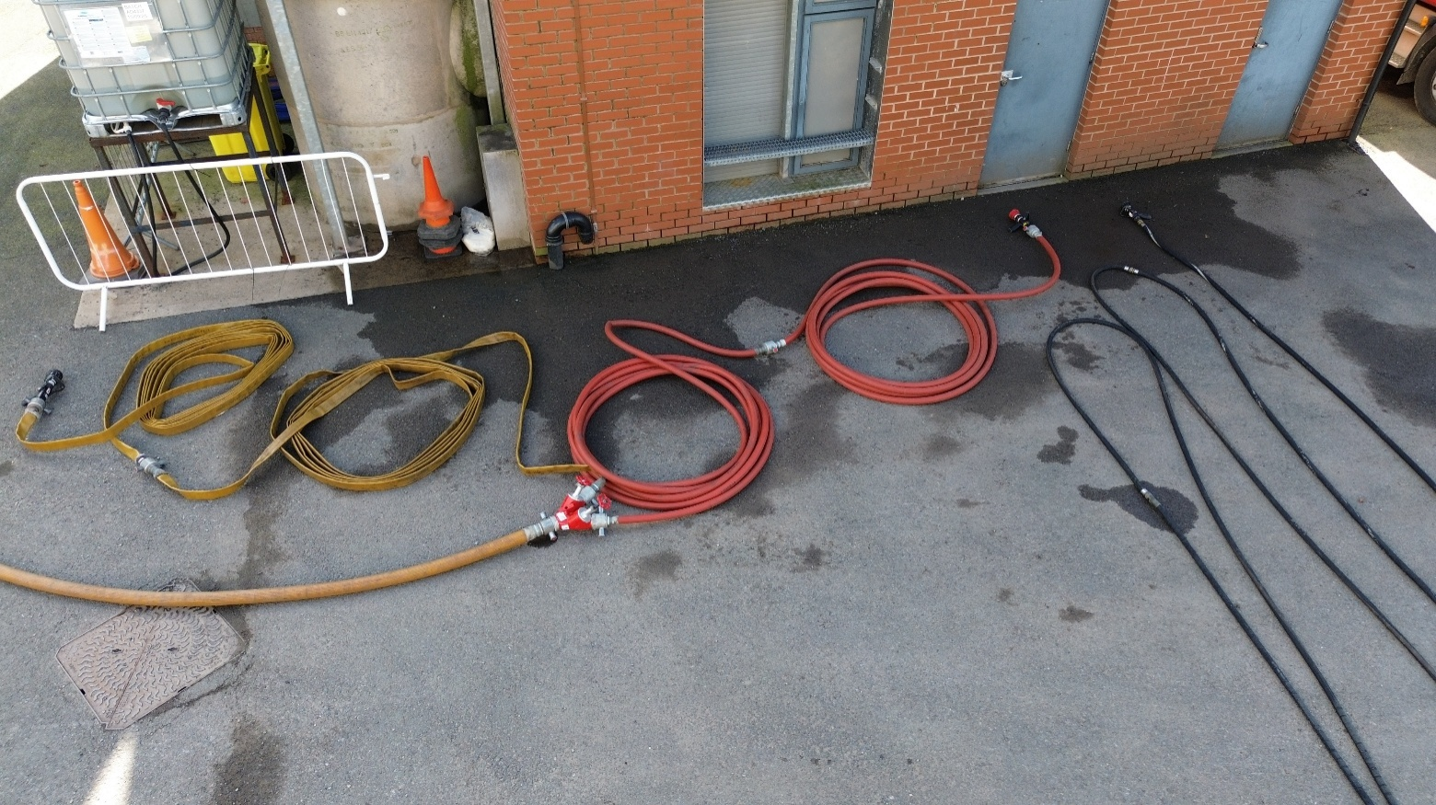
(Fig.3 – Close up of fire ground set up with hose reel selected as fire attack)

Operating principles
- The hose reel should be deployed from the nearest side of the appliance to the building entry point. The hose reel must be fully run off the drum to minimise frictional losses and ensure effective water delivery.
- To achieve a maximum flow of 150LPM from a 19mm hose reel, the appliance pressure should be set to 25bar.
- To achieve a maximum flow of 230LPM from a 22mm hose reel, the appliance pressure should be set to 40bar.
- 1x Dutch rolled 64mm hose (add additional 64mm lengths dependant on proximity of pump from entry point) from delivery no.2 (see Fig.2) into a dividing breeching to be positioned close to the entry point (see Fig.3).
- Delivery no.2 on each appliance from which interior firefighting is in operation, should be reserved for the ‘safety’ and ‘covering’ jet set up.
- Maximum 2x 38mm and/or 45mm hose (Cleveland load) from the right-hand outlet (think ‘Right Reserve’) of the dividing breeching terminating in a compartment branch to be charged as the ‘safety jet’. If additional distance is required into a structure, use 64mm prior to connecting 38/45mm hose.
- The safety jet can be utilised as the covering jet at the front face of the property if required.
- 2x 38 and/or 45mm and/or 64mm (Dutch 64 or cleveland 38/45) terminating in a main branch from the left-hand outlet of the dividing breeching to be used as a ‘covering jet’. This can be left uncharged until it is confirmed what sector it is required.
- It is good practice to ensure that high-pressure and low-pressure supplies for interior firefighting operations are provided from separate appliances. Therefore, as soon as practicable, any ‘safety’ or ‘covering’ jets should be transferred from the appliance supplying the hose reel to a secondary appliance on the incident ground. This transfer can be implemented immediately if two pumps are in attendance on arrival, or at the earliest opportunity following the arrival of the second appliance.

Fire Ground Set Up – Lay flat 38/45mm selected as Fire Attack
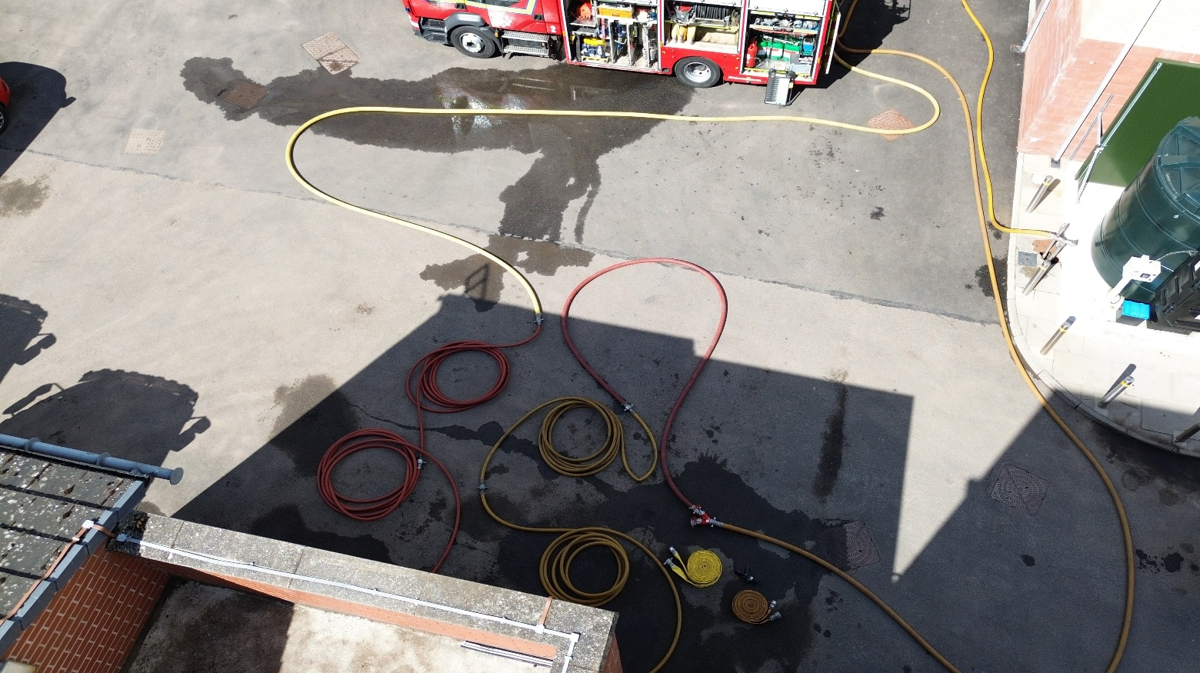
(Fig.4 - Aerial view of fire ground set up with lay flat 38/45mm selected as fire attack)

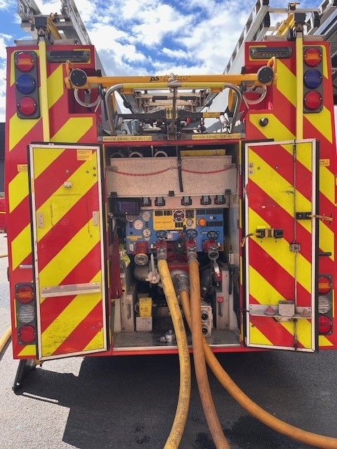
(Fig.5 – Appliance Bay view of fire ground set up with lay flat 38/45mm selected as fire attack)
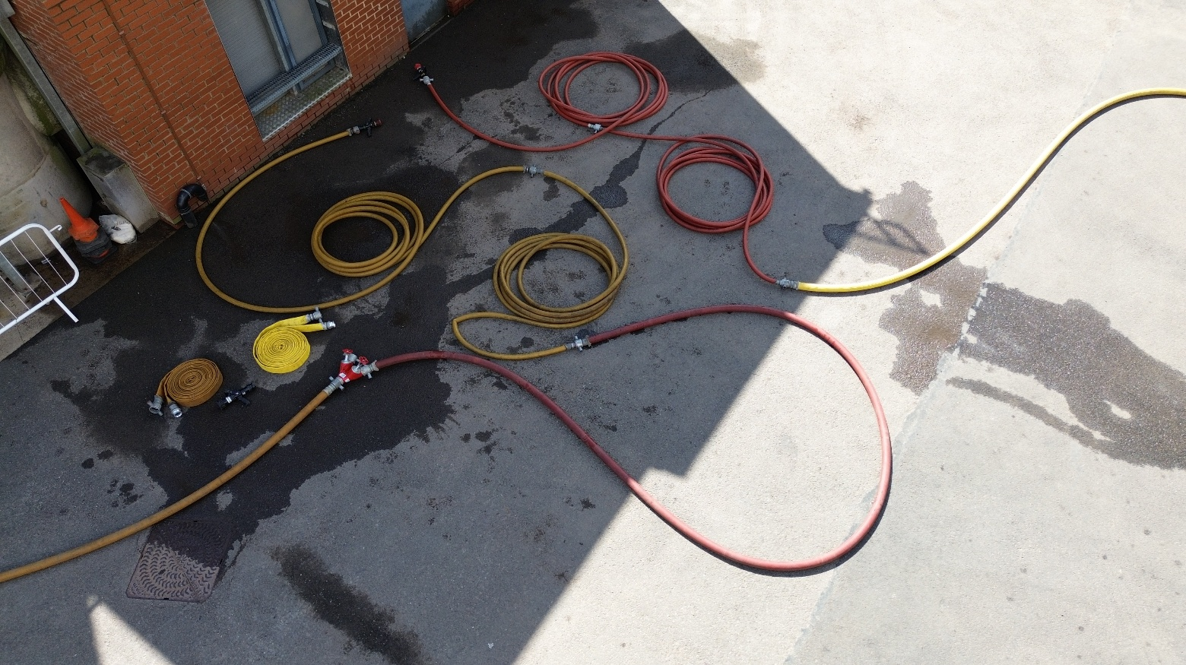
(Fig.6 – Close up of fire ground set up with lay flat 38/45mm selected as fire attack)

Operating principles
- 1x Dutch rolled 64mm hose (add additional 64mm lengths dependant on proximity of pump from entry point) from delivery no.1 (see Fig.5) into maximum 2x 38/45mm hose (Cleveland load) terminating in a compartment branch positioned close to the entry point (see Fig.6).
- Delivery no.1 on each appliance from which interior firefighting is in operation, should be reserved for the fire attack team. If more than one fire attack team is deployed using lay flat hose, they should have a dedicated appliance per team.
- 1x Dutch rolled 64mm hose (add additional 64mm lengths dependant on proximity of pump from entry point) from delivery no.2 (see Fig.5) into a dividing breeching to be positioned close to the entry point (see Fig.6).
- Delivery no.2 on each appliance from which interior firefighting is in operation, should be reserved for the ‘safety’ and ‘covering’ jet set up.
- Maximum 2x 38mm and/or 45mm hose (Cleveland load) from the right-hand outlet (think ‘Right Reserve’) of the dividing breeching terminating in a compartment branch (where available) OR main branch to be charged as the ‘safety jet’. If additional distance is required into a structure, use 64mm prior to connecting 38/45mm hose.
- The safety jet can be utilised as the covering jet at the front face of the property if required.
- 2x 38 and/or 45mm and/or 64mm (Dutch 64 or cleveland 38/45) terminating in a main branch from the left-hand outlet of the dividing breeching to be used as a ‘covering jet’. This can be left uncharged until it is confirmed what sector it is required.
- It is good practice to ensure that fire attack and safety/covering jet(s) for interior firefighting operations are provided from separate appliances. Therefore, as soon as practicable, any ‘safety’ or ‘covering’ jets should be transferred from the appliance supplying the fire attack delivery to a secondary appliance on the incident ground. This transfer can be implemented immediately if two pumps are in attendance on arrival, or at the earliest opportunity following the arrival of the second appliance.
- Refer to Flow & Pressure Matrix for appropriate appliance pumping pressures based on required flow rates.

