Protection

Statement of Change

Restructure

Statement of Change – Consultation Document
This statement of change contains a proposal which may result in a change to department structure, role responsibilities and workplaces. It seeks to clarify the process that will be followed for individuals who may be affected within the Protection team.
This document provides information in relation to proposals, the consultation period as well as the other stages of the process.
- Background

  - The purpose of the proposed restructure of the Protection department is to improve departmental capacity and resilience, enabling completion of the RBIP alongside increasing Protection workloads and emerging national risks and expectations. It aims to distribute resources to reflect the built environment risk in Cumbria, ensuring local inspector oversight linked in with local crews.

  - Increasing administrative workloads will be reduced through the recruitment of 2 Protection Team Coordinators, allowing more capacity for Protection activities.

  - Fire Investigation (FI) currently sits across individual Flexi Duty Officers (FDOs) rather than within a structured department, leaving the function without dedicated oversight, governance or budget, no centralised Continuous Professional Development (CPD), training pathways or quality assurance, and no accountability. This creates organisational vulnerability and limits CFRS’s ability to meet the FI Fire Standard requirements.

  - These changes will reduce organisational risk and better align the Service with statutory requirements, national standards and strategic objectives.

- What is the Process?

  - This Statement of Change sets out the impact of the service review on staff structures, roles and employees. It will be used to underpin engagement with staff on the proposals and is designed to ensure a framework that allows both a consistent approach yet allow an understanding that an element of flexibility may be required depending on issues arising.

  - The process will follow Cumbria Fire & Rescue Service’s Managing Change Procedure.

- Engagement

  - There will be a 30-day engagement period for all staff in scope of the review. An initial face to face briefing will begin the process, setting out the proposals and engagement process. There will be an opportunity to ask questions of service managers, and the briefing will be attended by a HR advisor with Trade Unions representatives also invited to support staff.

  - The Statement of Change will be made available to all staff and additional FAQs relating to the service proposals will be posted on the Managing Change section of the CFRS website. These will be regularly updated to reflect questions raised during the engagement process.

  - Engagement opportunities will be tailored to the specific needs of the service and employees in scope and will be proportionate to the type of change proposed. Engaging with staff will consist of one to one or group meetings if requested and a further group meeting at the mid-point. A final group meeting will be held following the closure of the engagement period, once all feedback has been considered and final decisions have been made.

- Trade Unions

  - CFRS is committed to work closely with trade union colleagues through this period of change.

  - Trade Union representatives will be briefed at various stages of the process ahead of communications with affected employees.

  - Trade Union representatives will also be invited to attend all engagement meetings with staff. There will be the opportunity at the end of the engagement meetings for Trade Unions to have initial discussion with their members. Trade Unions can also accompany their members to one to one and appeal meetings.

- Review, Decision and Outcome

  - We will aim to notify all in scope employees of the outcome within 2 weeks of the engagement process ending. This will be accompanied by an outline timetable for the process.

  - Should there be a need to extend the 2-week decision period as a result of significant issues raised, then all staff will be notified as early as possible, with an explanation for why an extension is required.

- Assimilation Processes

  - The full details of the assimilation process are contained in the Managing Change Policy.

  - Whilst engagement is taking place it is important that all ‘in scope’ employees examine their current role profile to ensure it accurately reflects the reality of their substantive role. Amendments to job descriptions will only be accepted with the relevant line manager agreement.

  - See the managing change policy for Assimilation Outcomes

- What Do We need to Achieve through this Review and Restructure?

  - The aims of the review are to: -

- Improve departmental capacity and resilience
- Increase professional fire safety knowledge and qualifications across the Service
- Align with national standards and CRMP objectives
- Embed Fire Investigation (FI) within Protection to strengthen governance and assurance
- Improve evidence led ability to target risk

- Scope

  - The posts in scope of the proposed service review are:

Post Title | Number of Posts
Watch Manager | 4
Protection Advisor | 3
Temporary Crew Manager | 2

- Future Structure and Staffing Proposals

  - The current staffing structure 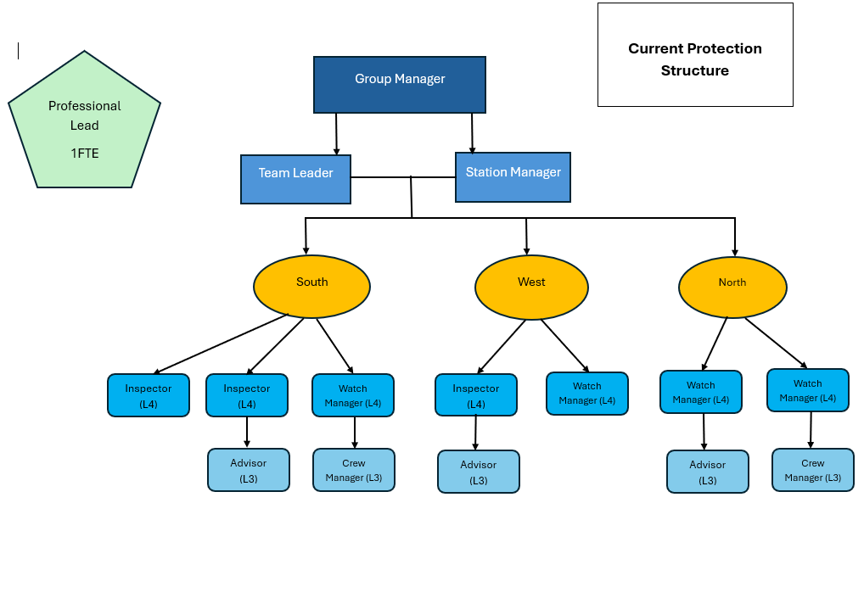
  - The proposed new structure for consultation will consist of:

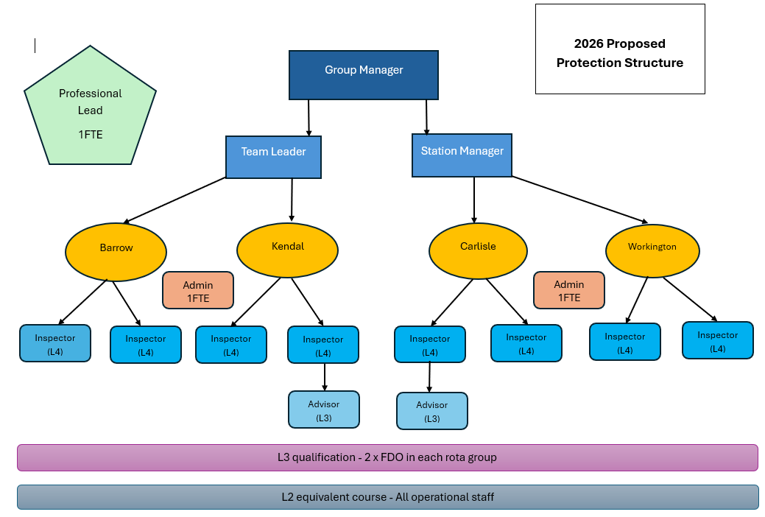
(Note: 2 of the L4 Inspectors will be WMs, 1 of the L3 Advisors will be a temporary CM)

  - The proposed FI structure
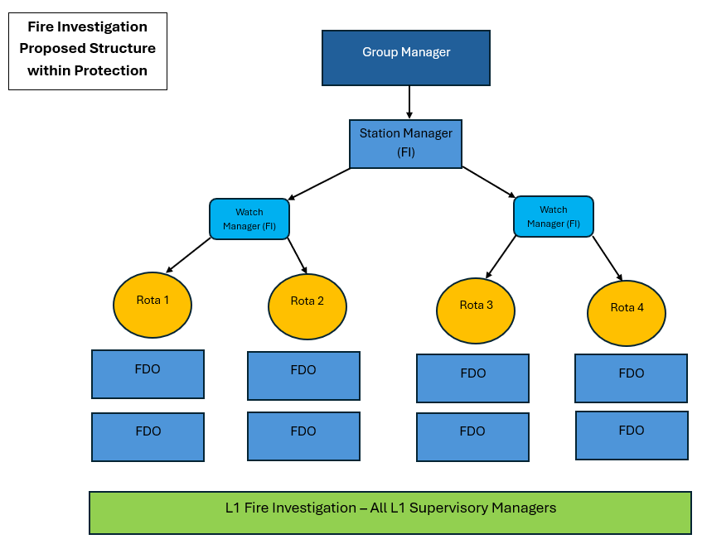

  - If agreed following consultation, this would result in:

Creation of:
- 3 more Inspector posts
- 2 Protection Team Coordinator posts
- Base location responsibilities

Removal of:
- 2 WM posts (1 WM redeployed)
- 2 advisor posts
- 1 temporary CM

Change in role responsibilities for 2 WM posts

Wage cost savings would be realised of £8,592

- Approach for the establishment of the proposed structure

  - The proposed timeline for the review is enclosed.

- How to engage with the reshaping proposals

  - All consultation and supporting information will be made available on the Employee Pages on the CFRS Website following the first staff consultation meeting. A hard copy information pack will be provided at the end of the first consultation meeting for staff without access to the CFRS website.

  - Communication methods and information will be available in a range of formats where required to ensure equal access to the documentation for all employees.

  - All employees in scope of the reshaping will be offered at least, one 1:1 meeting during the reshaping process. The purpose of this is to seek the views and ideas of staff in relation to the proposals and provide as much opportunity for personal circumstances to be listened to, collated and considered.

  - To request a 1:1 or group meeting with management, please contact your line manager.

  - To ask questions, provide comments or submit feedback on the proposals, please contact Takara Hanks, Senior HR Advisor on takara.hanks@cumbriafire.gov.uk or HR@cumbriafire.gov.uk if your query is time-sensitive. This will ensure questions are promptly directed to the most appropriate person to answer and responses will be included in the service-related FAQs unless they relate only to the individual employee. Staff are encouraged to read the FAQs already on the website as a response may already have been provided.

  - Members of the recognised Trade Unions may wish to give their feedback through their Trade Union representative.

  - The Managing Change pages of the CFRS Website are to be kept up to date to containing a range of information to support employees through the change process. You are encouraged to view this website on a regular basis during the reshaping process.

- Timescales

  - The proposed timeline for the review is set out in the attached Appendix 1.

Name
Area Manager Jennie Schamp – Head of Protection

Appendices

Appendix 1 - Timetable for complex change

DATE/S | ACTIVITY
Phase 1 - Information exchange/engagement
29th April 2026 | Meeting with staff in scope (Trade Unions invited)  Consultation process starts
As required | Individual meetings available upon request One to Ones- Employees can be accompanied by Trade Union representatives
14th May 2026 | Mid-Point staff meeting (Trade Unions Invited)
29th May 2026 | Consultation process closes
Phase 2 - Decision
w/c 1st June 2026 | Collation and review of feedback from staff and Trades Unions and reflection of structure proposal.
4th June 2026 | Final Decision Staff meeting (Trade Unions Invited)  - Final structure released  - Notice given of timescales  Outcome letters and associated documentation sent out to all employees in scope, following final meeting.
Phase 3 - Implementation
TBC | Change implemented:  - Communications to wider service on changes.  - Transition to new structure

